Om Gupta (EXT)

Datamato  Pune

PROD-BPD Documentation Pre-Upgrade

Index

**1] PROD-BPD Version 2**

**2] Home** 3

**3] Blueprints** 3

**3.1] Default 3**

**3.1.1] BPD_imported** 3

3.1.1.1] demo 3

3.1.1.1.1] demoBP 4

3.1.1.1.2] envprov 4

3.1.1.1.3] linux_prov **5**

3.1.1.1.4] linux2 5

3.1.1.1.5] poc 6

**3.1.2] Viewer** 7

**3.2] Internal Team** 7

3.2.1] ContentLibrary **8**

3.2.2] FetchTemplateID 8

3.2.3]Linux 9

3.2.4] MISCELLANEOUS-TEST 9

3.2.5] TEST-DYNAMIC-DISK 10

3.2.6] UCD-AEP-Blueprint **10**

3.2.7] UCD-AEP-Master 10

3.2.8] UCD-AEP-Master-MOD 11

3.2.9] UCD-AEP-Testing 11

3.2.10] UCD-AEP-Testing-Linux 12

3.2.11] UCD-AEP-Testing-Windows **12**

3.2.12] UCD-ALIAS 13

3.2.13] VM-Folder-Creation 13

3.2.14] Windows 14

**4] Environment** 15

4.1] Terraform-12 (TERRAFORM) **15**

4.2] Terraform (TERRAFORM) 15

**5] Repositories** 15

**6] Settings** 18

**6.1] Users** 18

6.1.1] Users tab 19

6.1.2] Groups tab 19

6.1.3] Edit tab **20**

**6.2] Roles** 20

6.2.1] Admin 20

6.2.2] Blueprint Manager 20

6.2.3] Environment Manager 21

6.2.4] Observer **21**

6.2.5] Participant 22

6.2.6] QA Manager 22

**6.3] Teams** 23

**6.3.1] Internal Team** 23

6.3.1.1] Members **23**

6.3.1.2] Cloud Connections 23

6.3.1.3] Orchestration Connection 24

**6.3.2] Release Team** 25

6.3.2.1] Members 25

6.3.2.2] Cloud Connections **25**

6.3.2.3] Orchestration Connection 26

**6.3.3] UCD Automation Team** 26

6.3.3.1] Members 26

6.3.3.2] Cloud Connection **26**

6.3.3.3] Orchestration Connections 27

**6.4] Orchestrations** 27

6.4.1] Terraform 27

6.4.2] Terraform-12 28

**6.5] Cloud Connections 28**

6.5.1] VC-AL-MGMT 28

6.5.2] VC-AL-N-WEB 29

6.5.3] VC-AL-WEB **29**

6.5.4] VC-BL-N-WEB 30

6.5.5] VC-BL-WEB 30

6.5.6] VC-CL-N-WEB 31

6.5.7] VC-CL-WEB **31**

6.5.8] VC-DE-N-WEB 32

6.5.9] VC-DE-WEB 32

**6.6] Modules** 33

**6.7] System Settings** 34

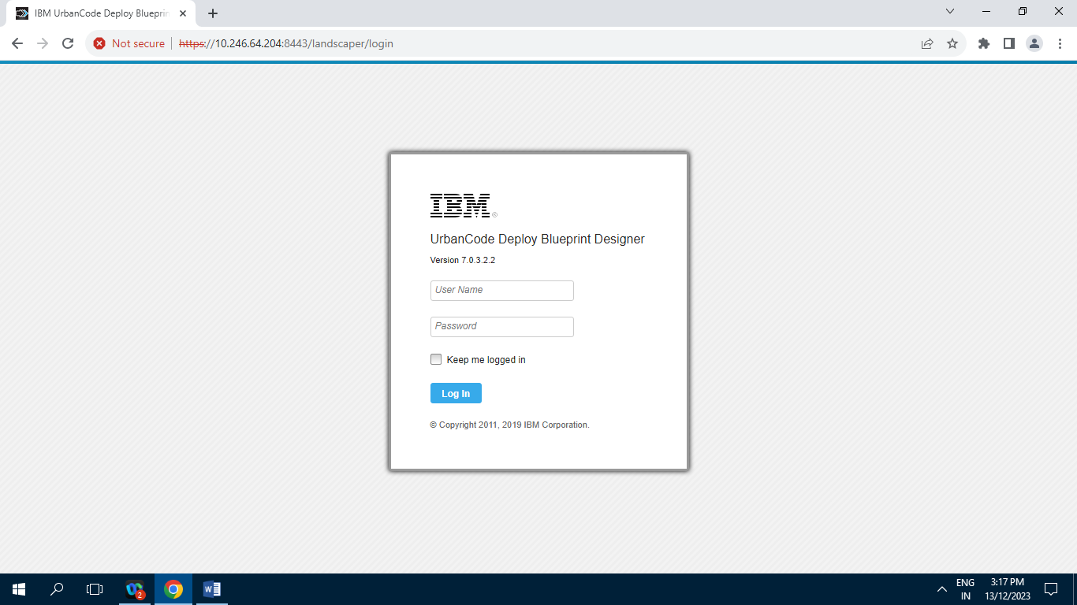

**1] PROD-BPD Version :**

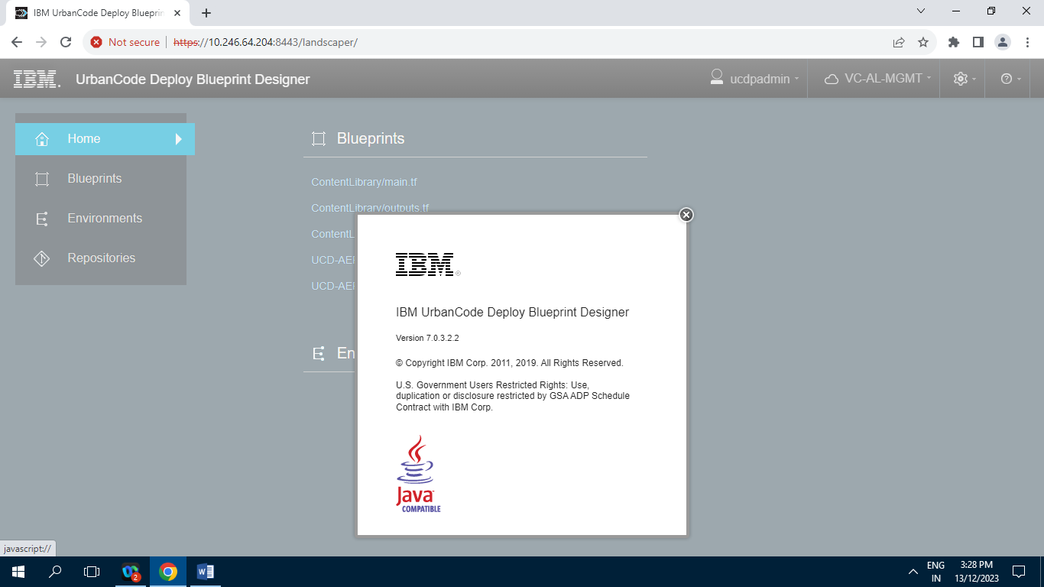

**2] Home :** 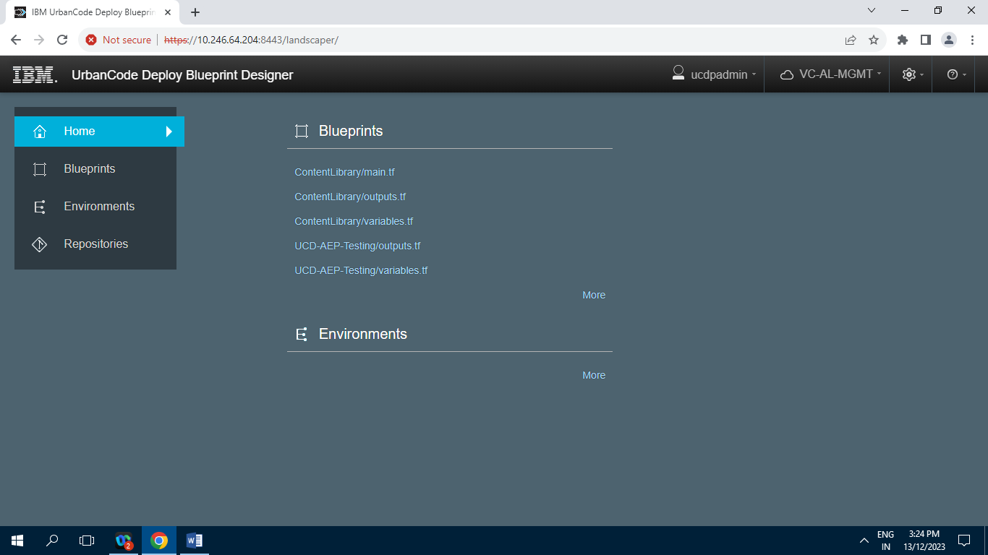

**3] Blueprints :**

**3.1] Default**

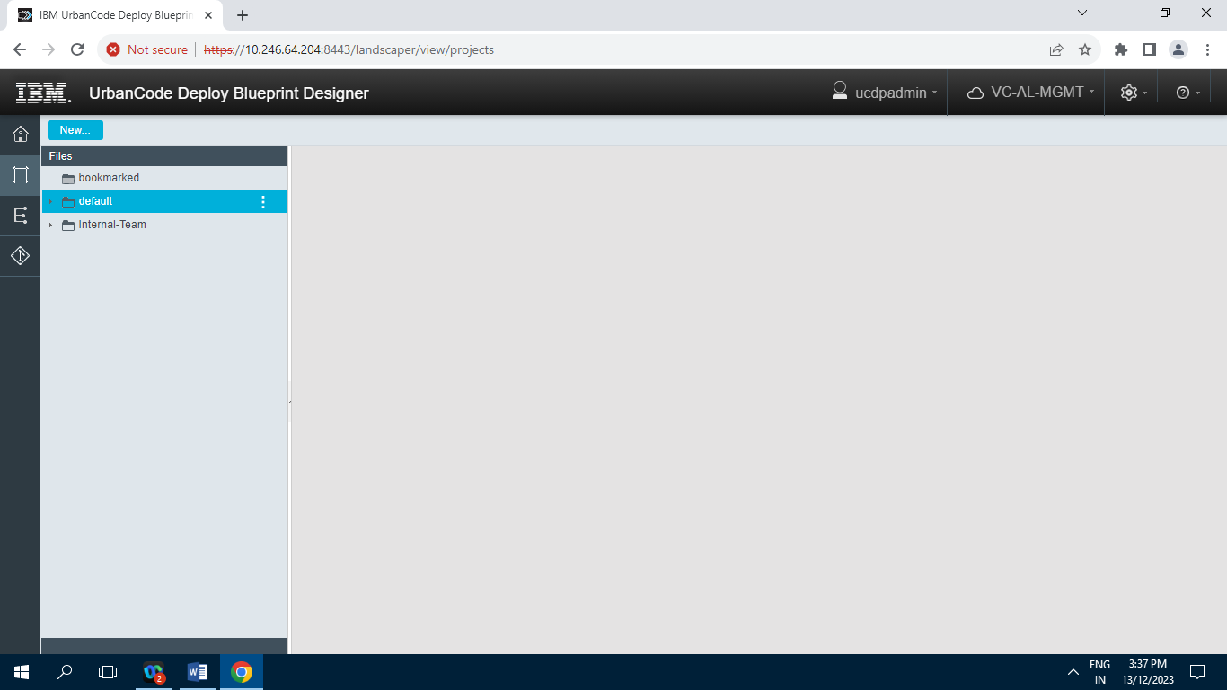

**3.1.1] BPD_imported**

**3.1.1.1] demo**

**3.1.1.1.1] demoBP**

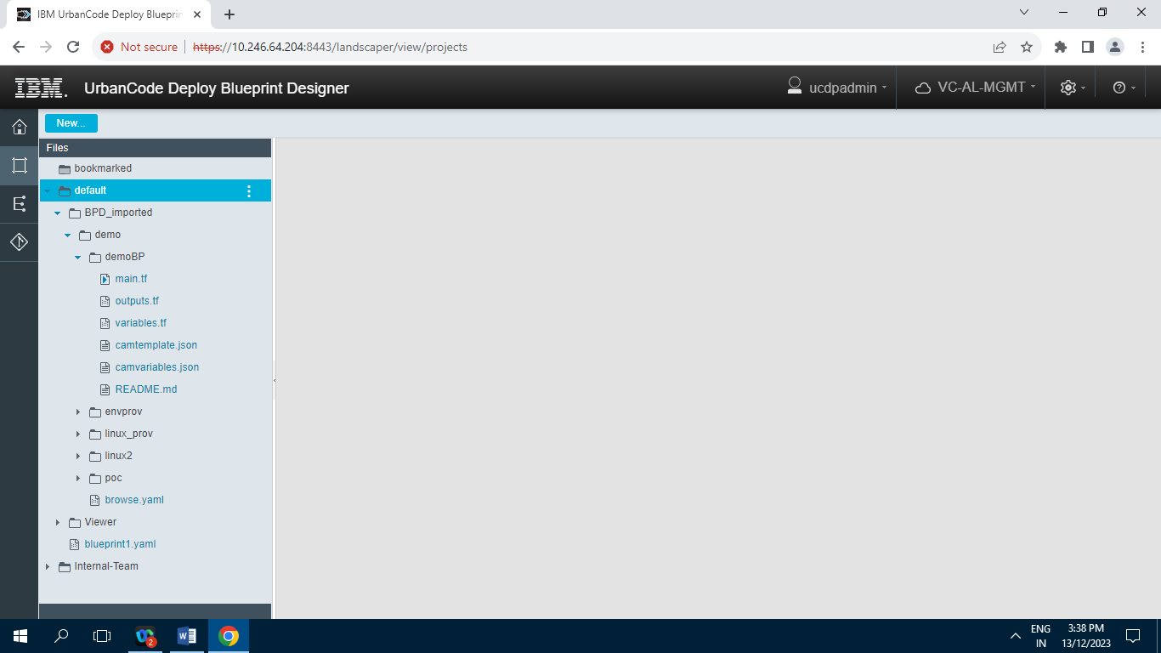

**3.1.1.1.2] envprov**

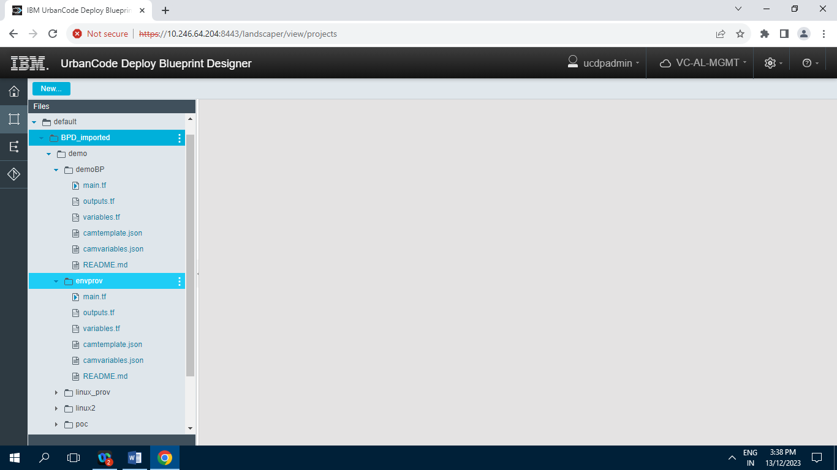

**3.1.1.1.3] linux_prov**

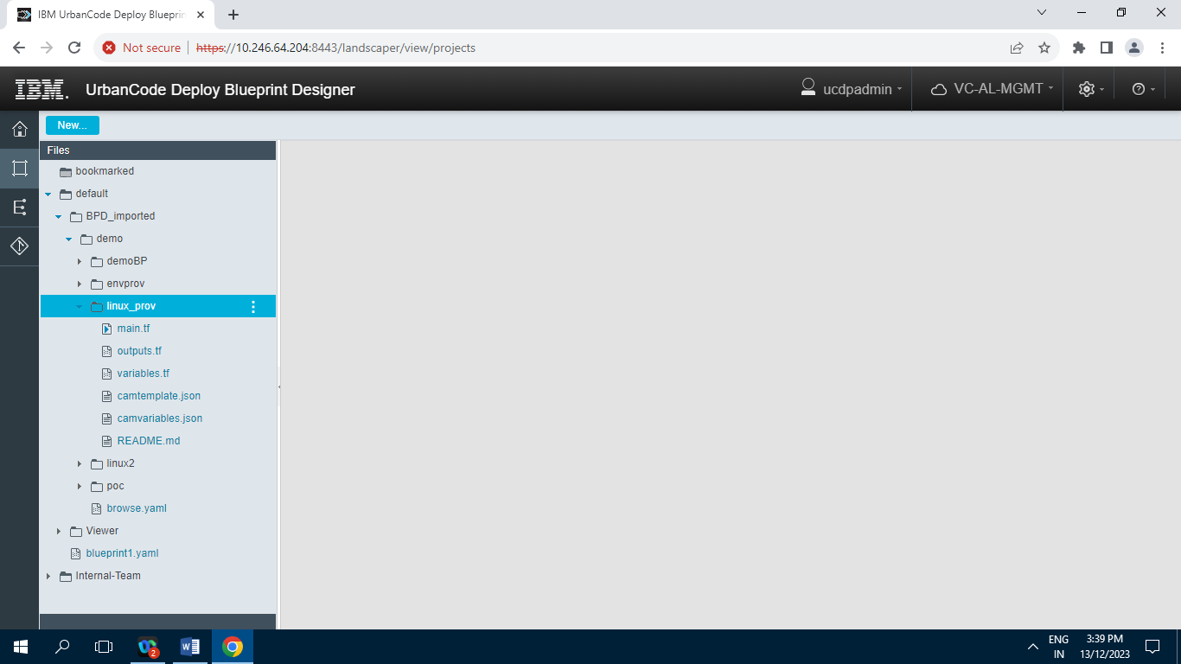

**3.1.1.1.4] linux2**

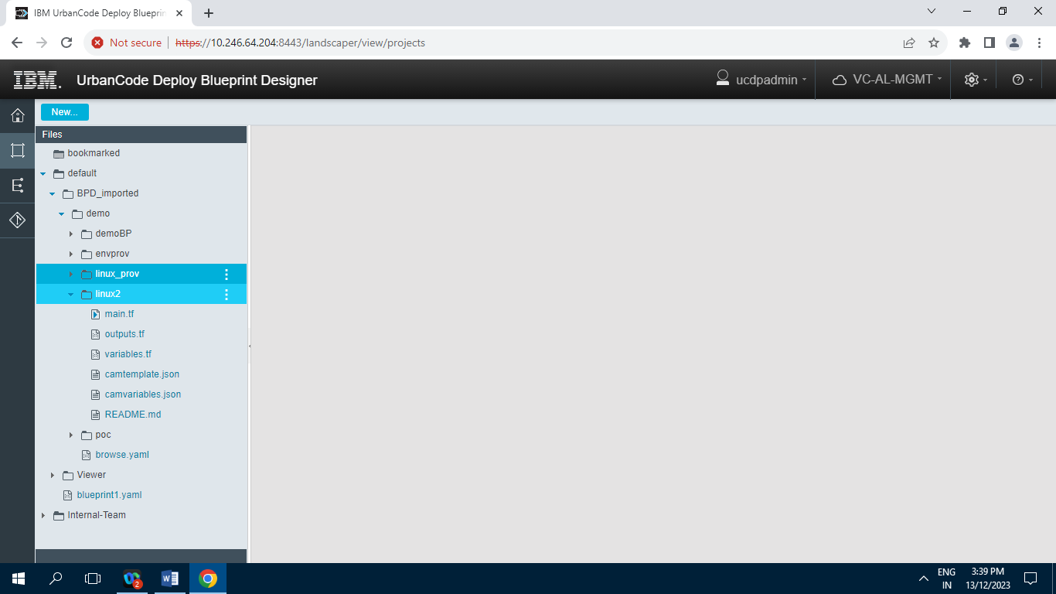

**3.1.1.1.5] poc**

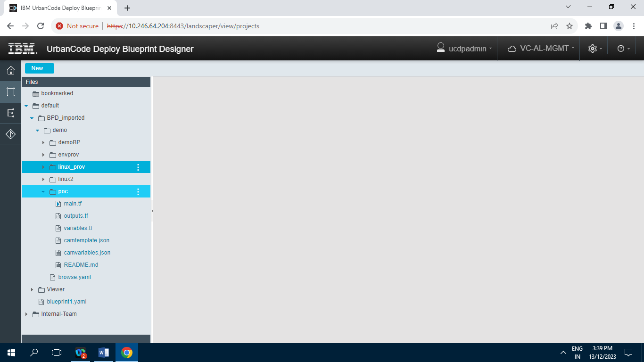

**Browse.yaml**

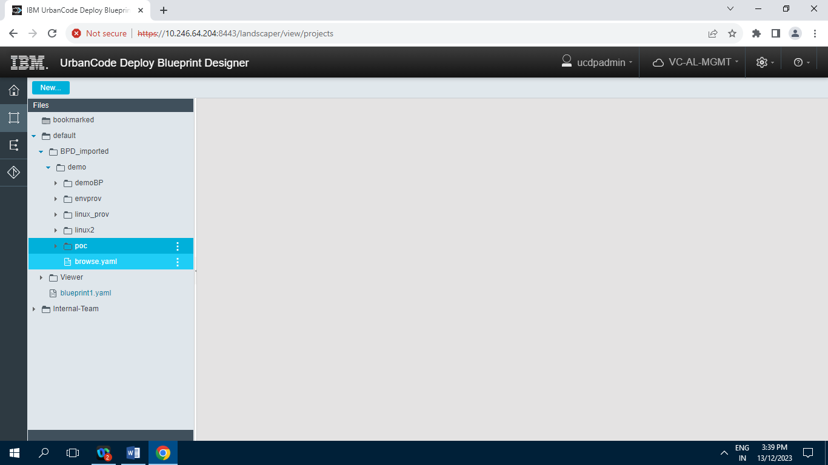

**3.1.2] Viewer**

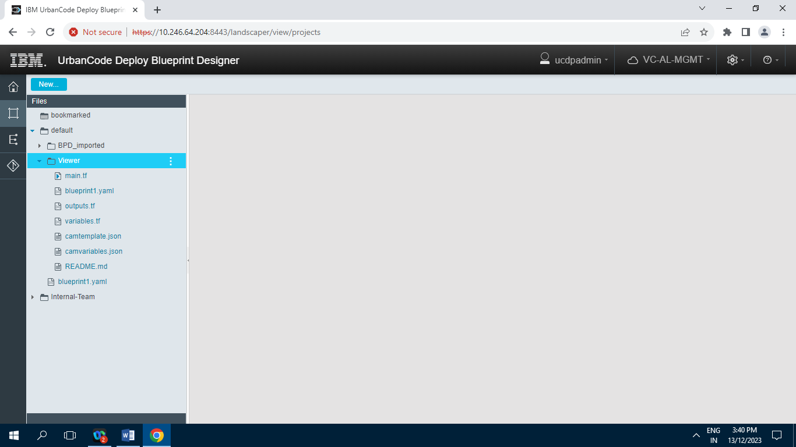

**3.2] Internal Team :**

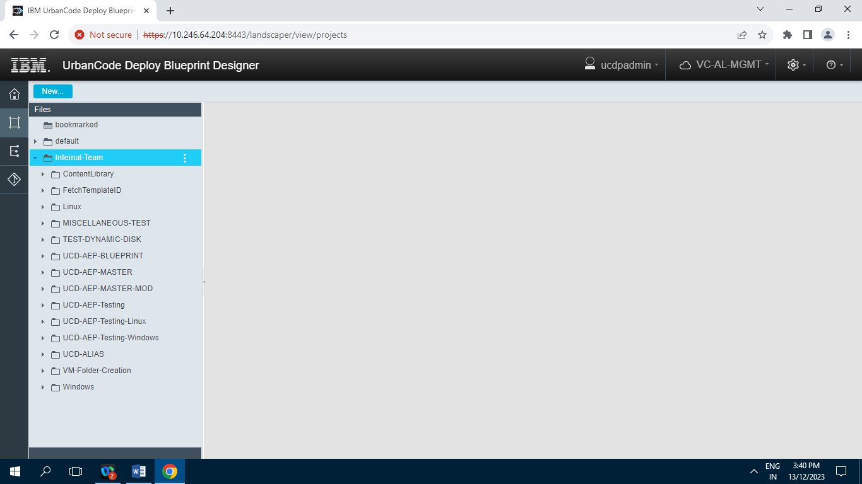

**3.2.1] ContentLibrary :**

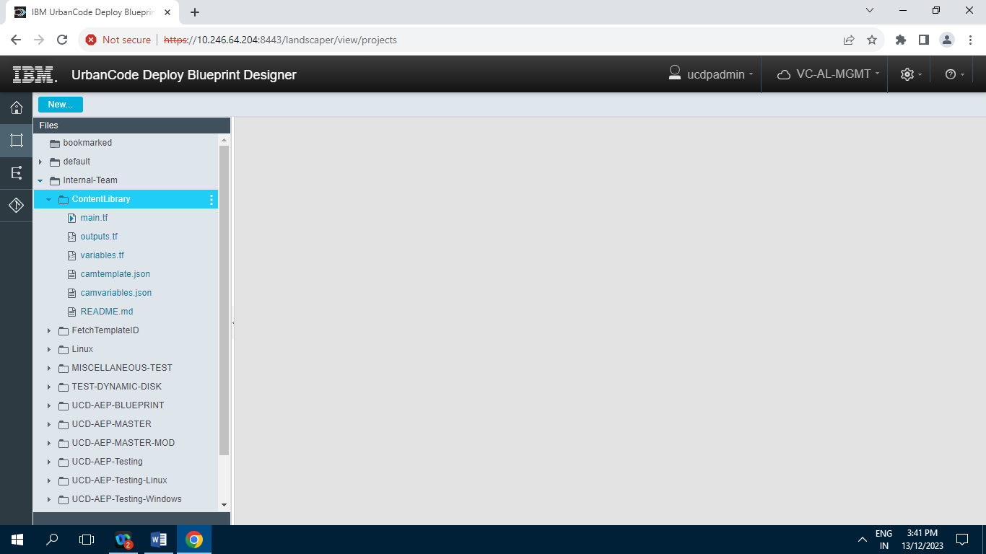

**3.2.2] FetchTemplateID**

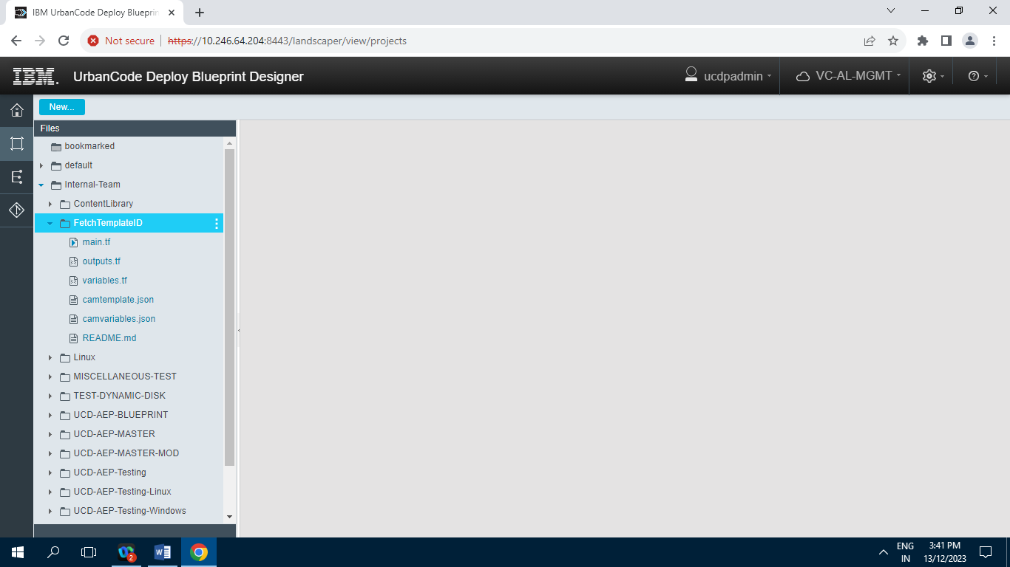

**3.2.3]Linux**

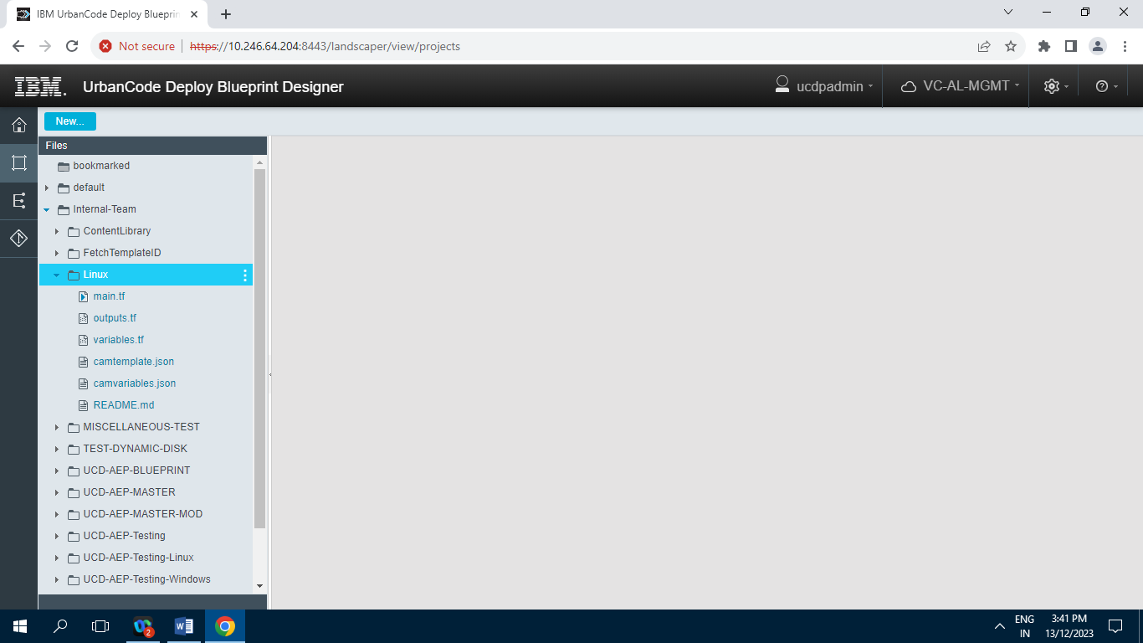

**3.2.4] MISCELLANEOUS-TEST**

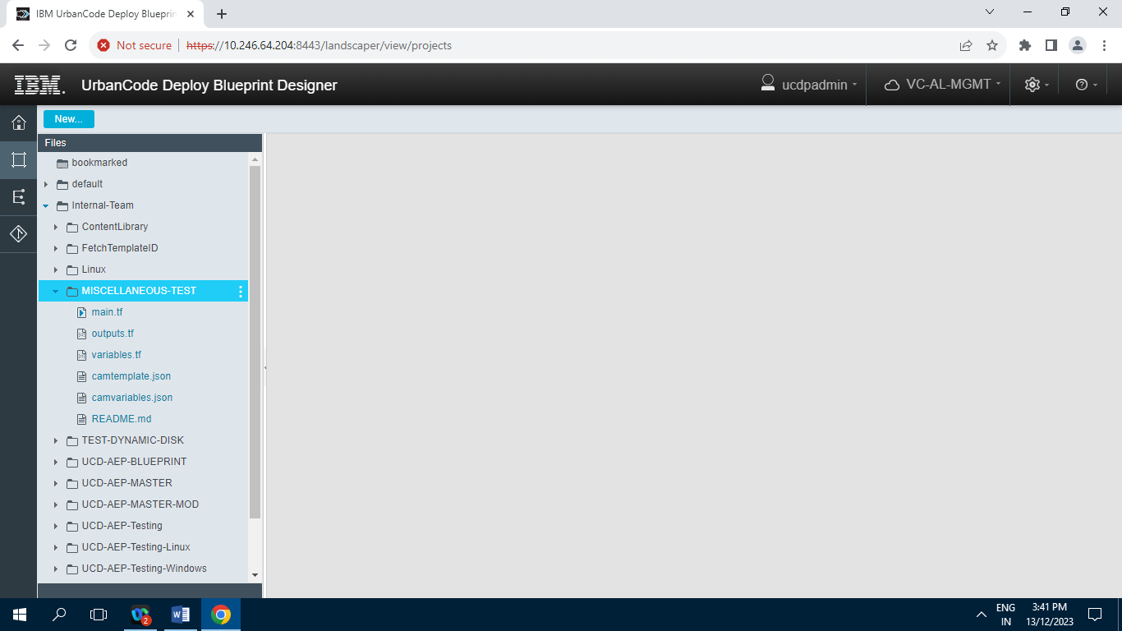

**3.2.5] TEST-DYNAMIC-DISK**

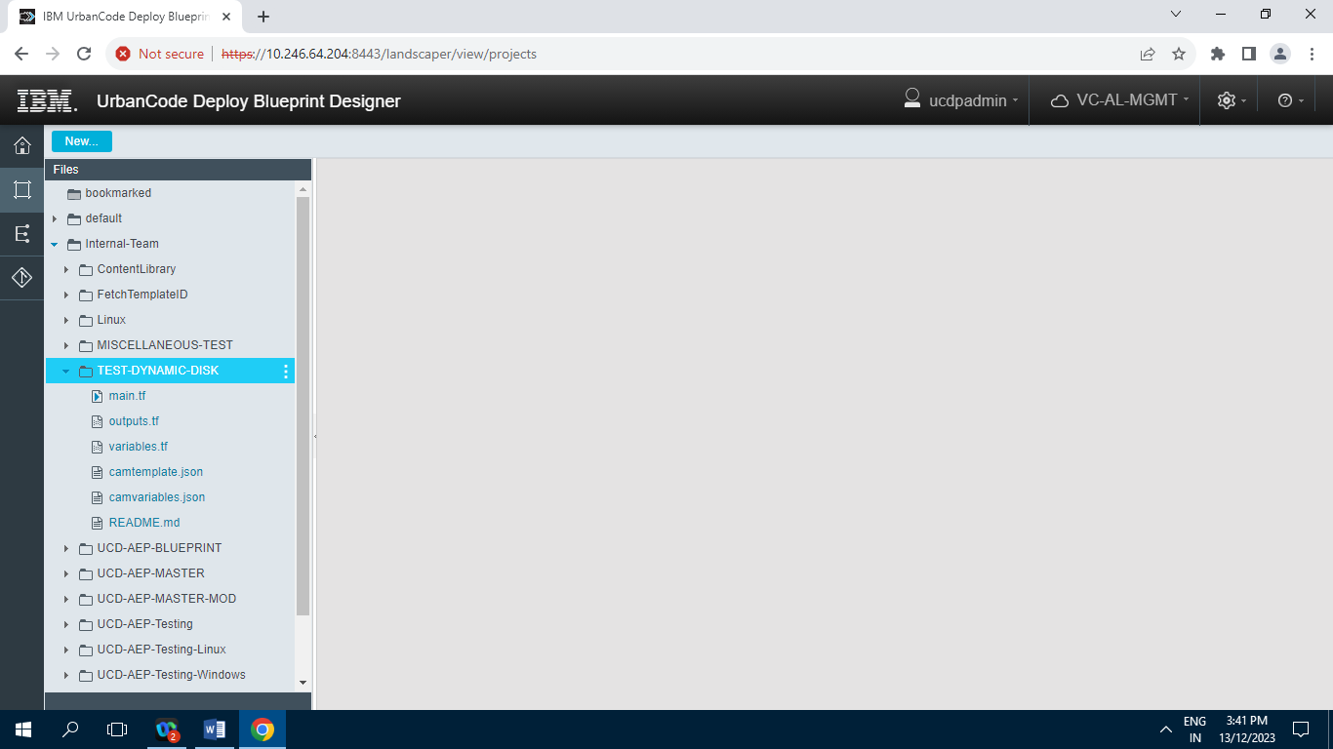

**3.2.6] UCD-AEP-Blueprint**

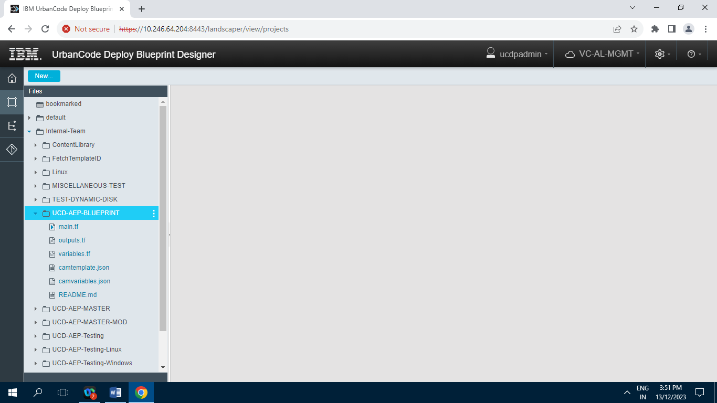

**3.2.7] UCD-AEP-Master**

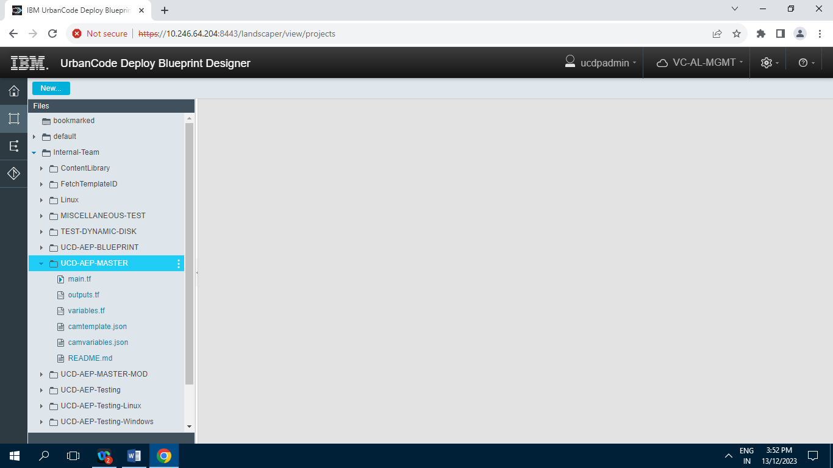

**3.2.8] UCD-AEP-Master-MOD**

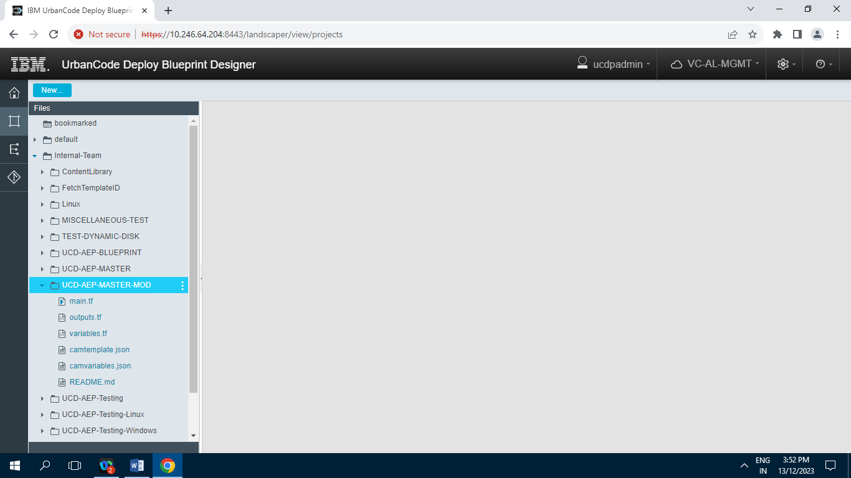

**3.2.9] UCD-AEP-Testing**

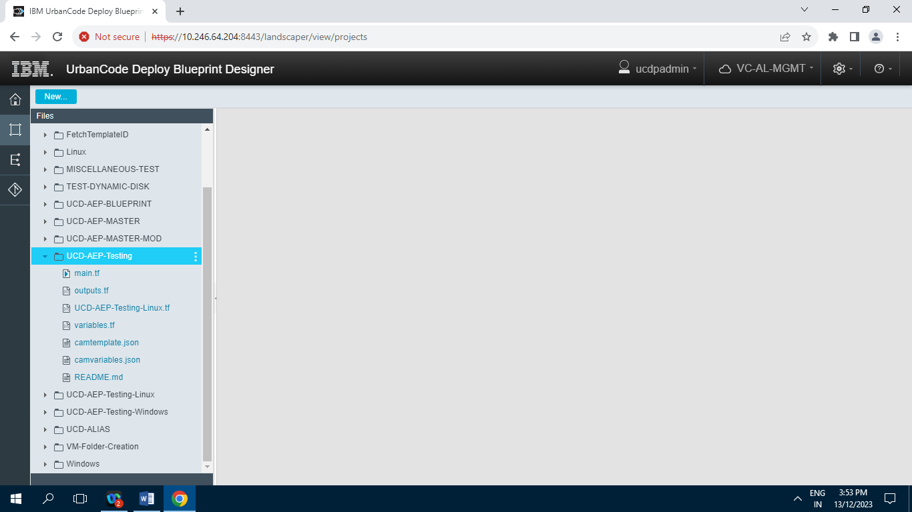

**3.2.10] UCD-AEP-Testing-Linux**

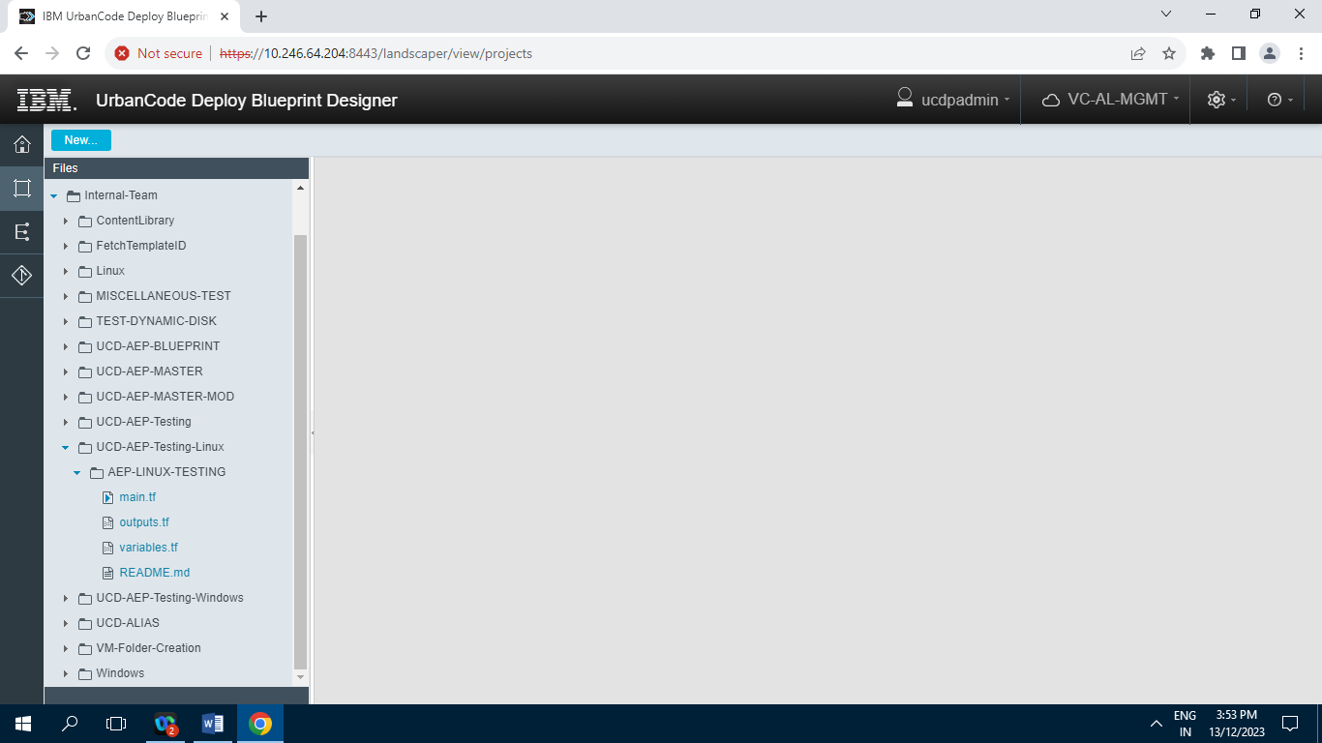

**3.2.11] UCD-AEP-Testing-Windows**

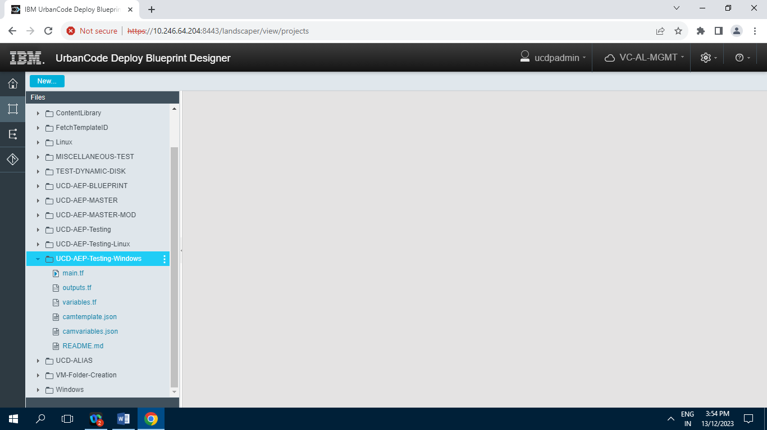

**3.2.12] UCD-ALIAS**

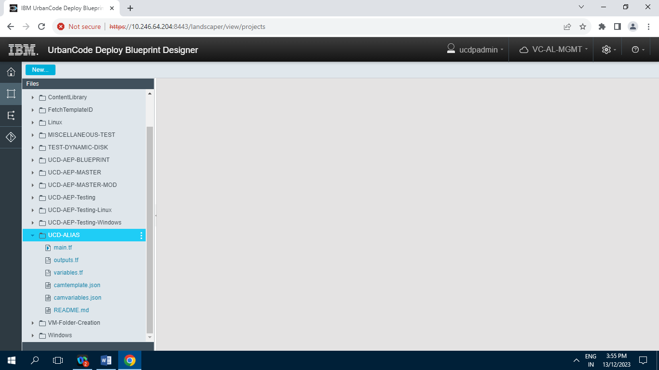

**3.2.13] VM-Folder-Creation**

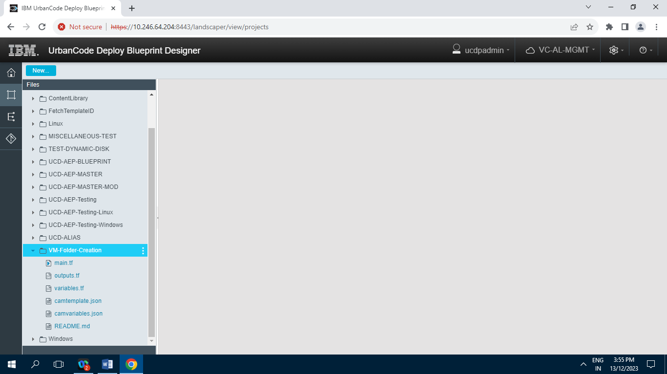

**3.2.14] Windows**

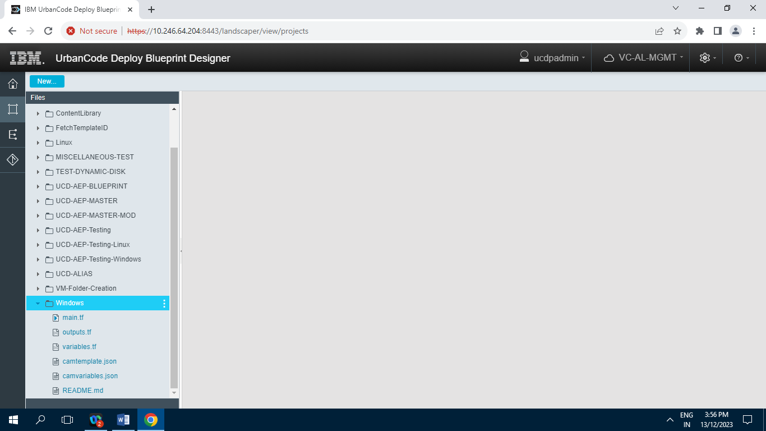

**4] Environment :**

**4.1] Terraform-12 (TERRAFORM)**

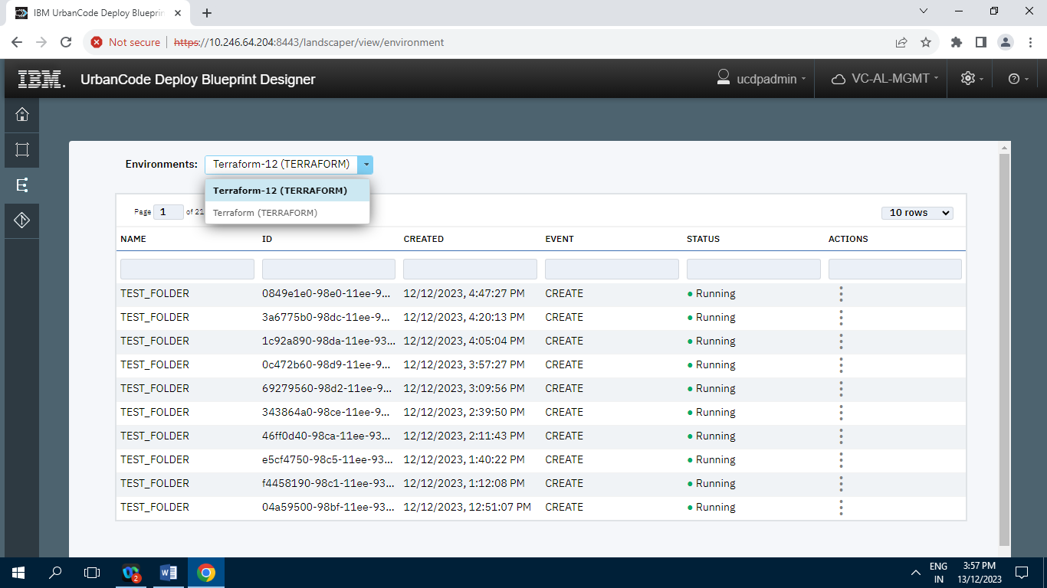

**4.2] Terraform (TERRAFORM)**

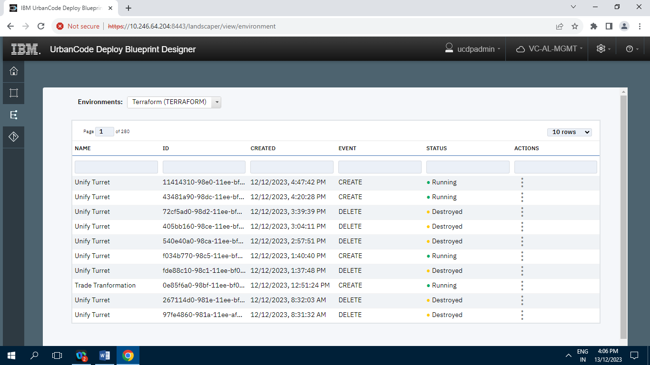

**5] Repositories :**

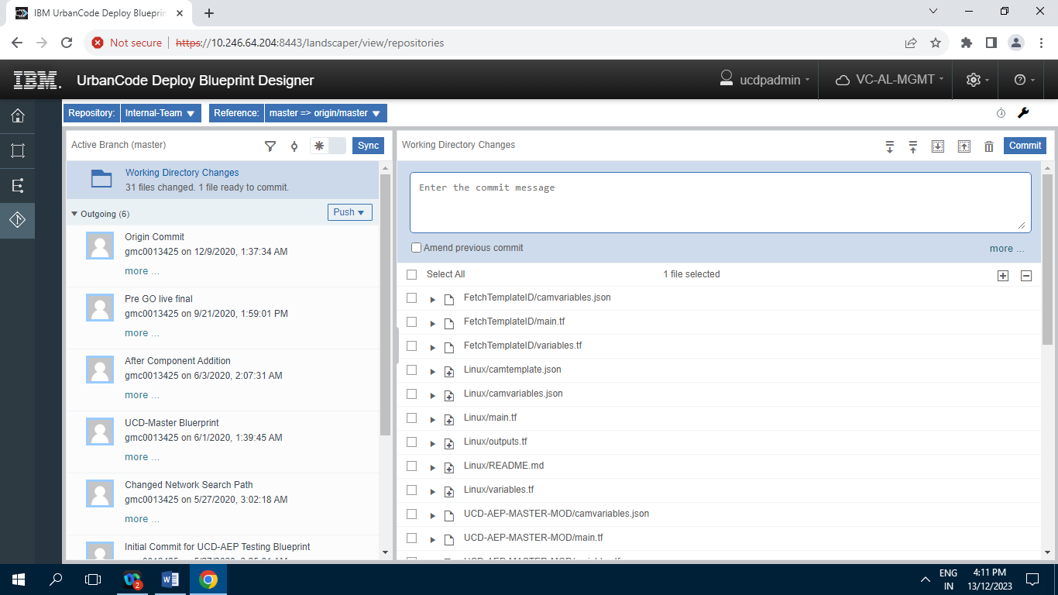

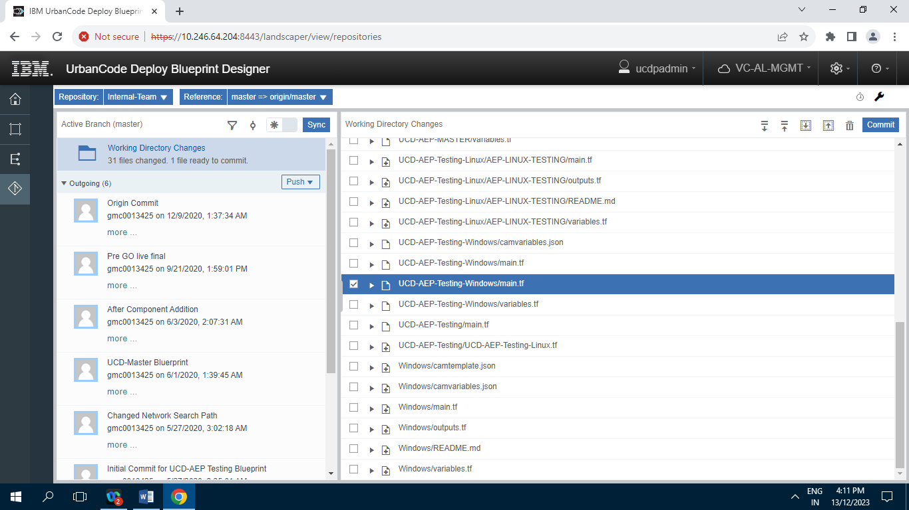

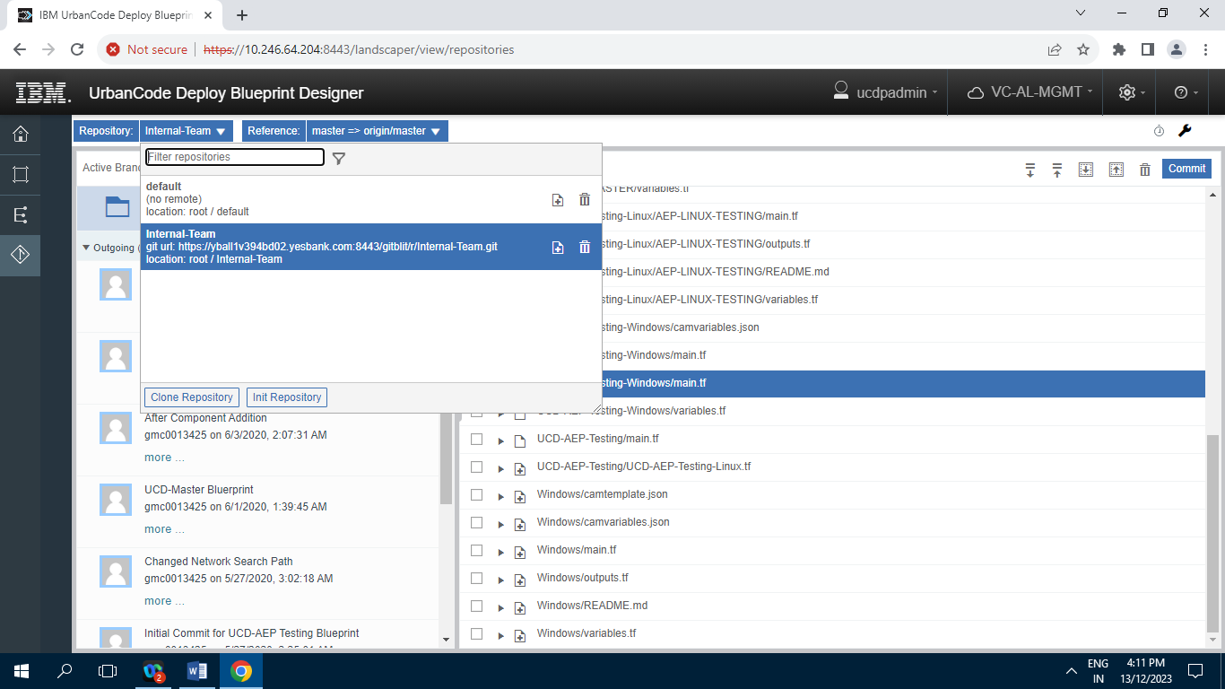

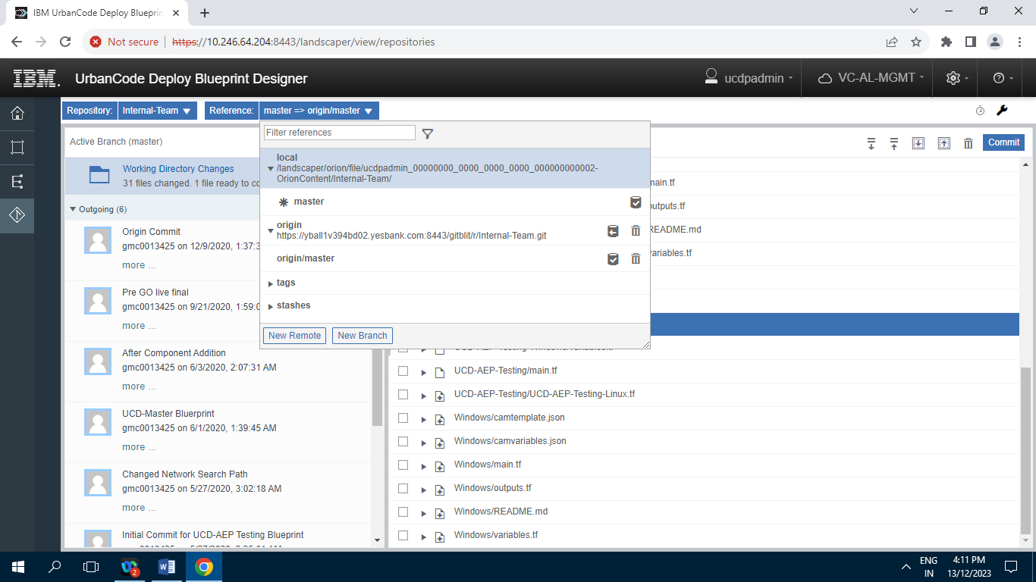

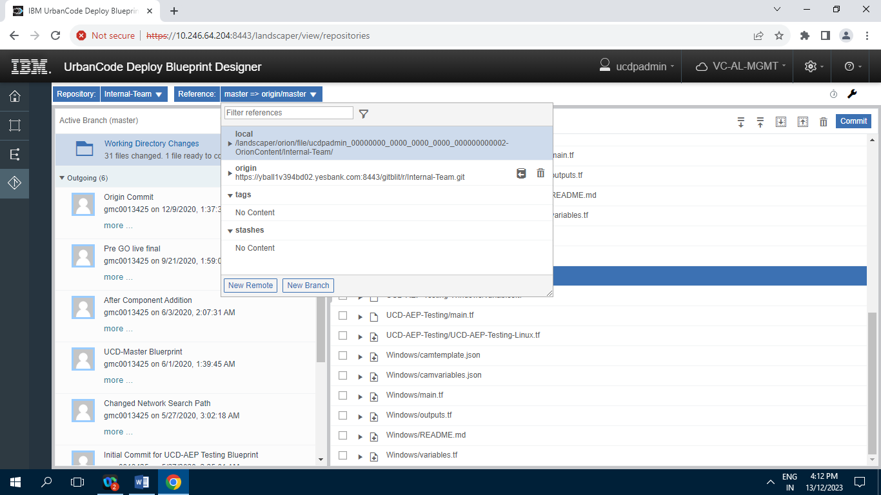

**6] Settings :**

**6.1] Users :**

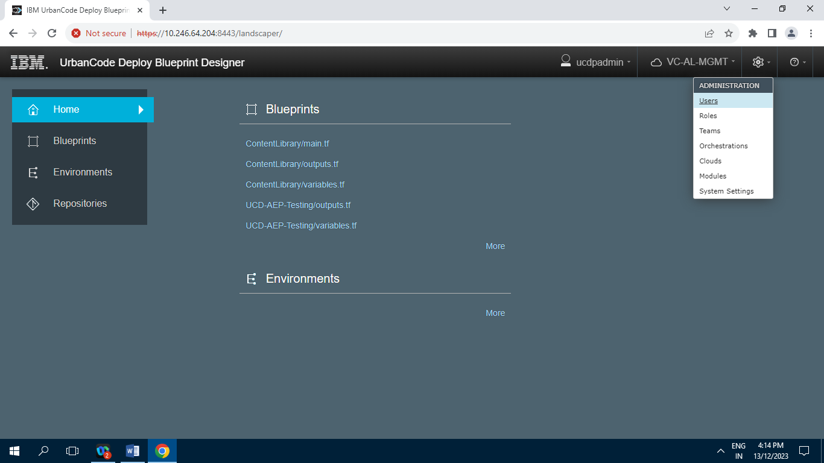

**6.1.1] Users tab :**

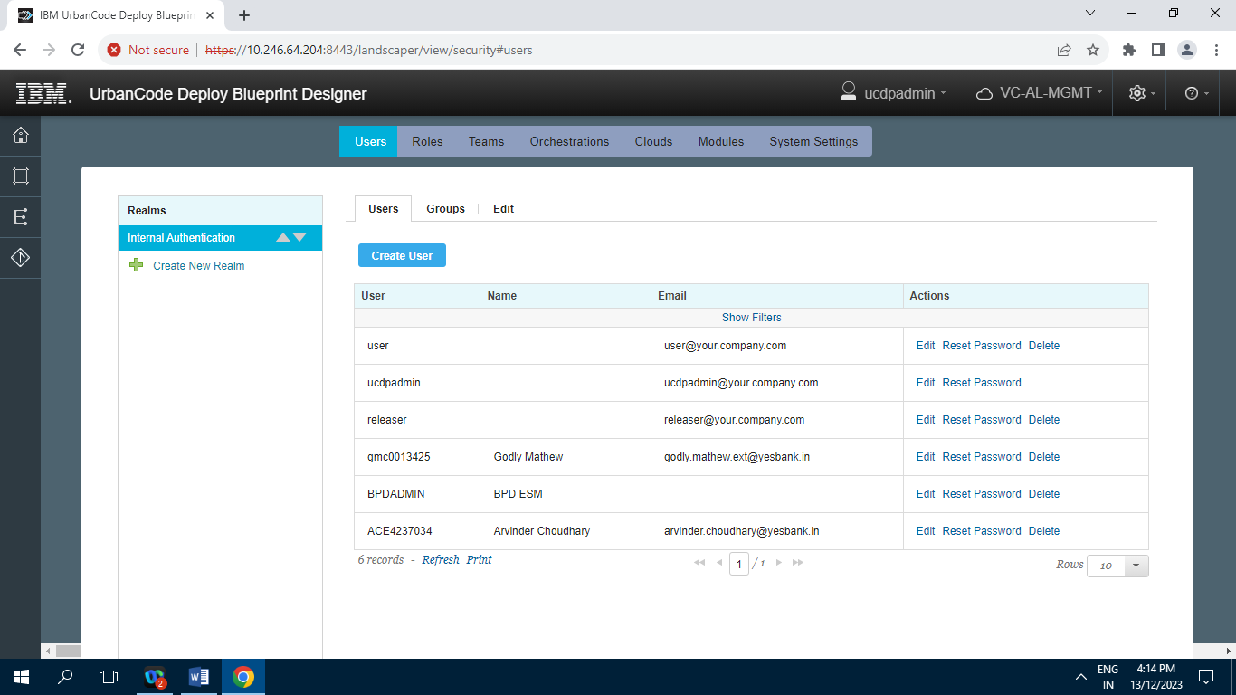

**6.1.2] Groups tab :**

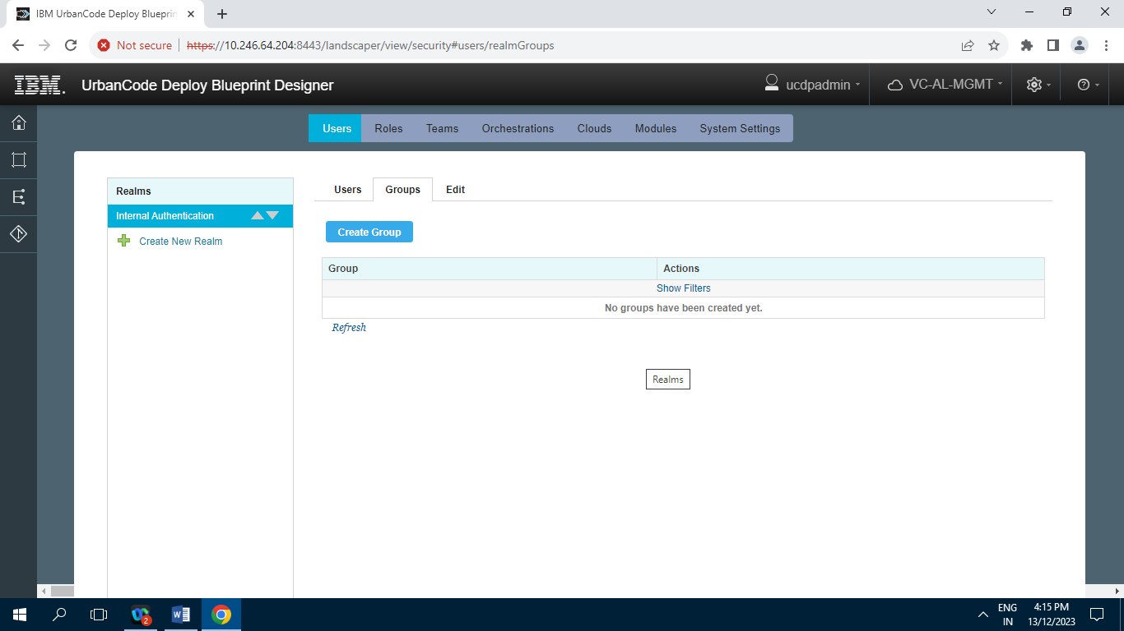

**6.1.3] Edit tab :**

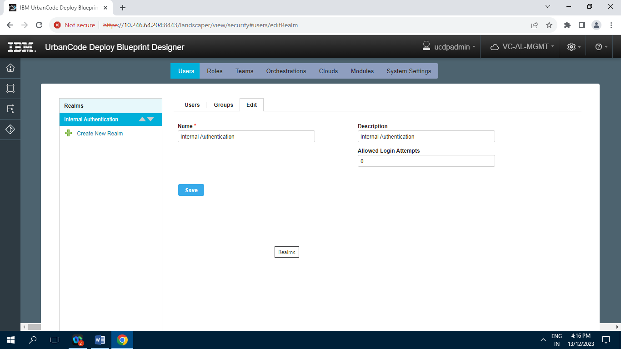

**6.2] Roles :**

**6.2.1] Admin**

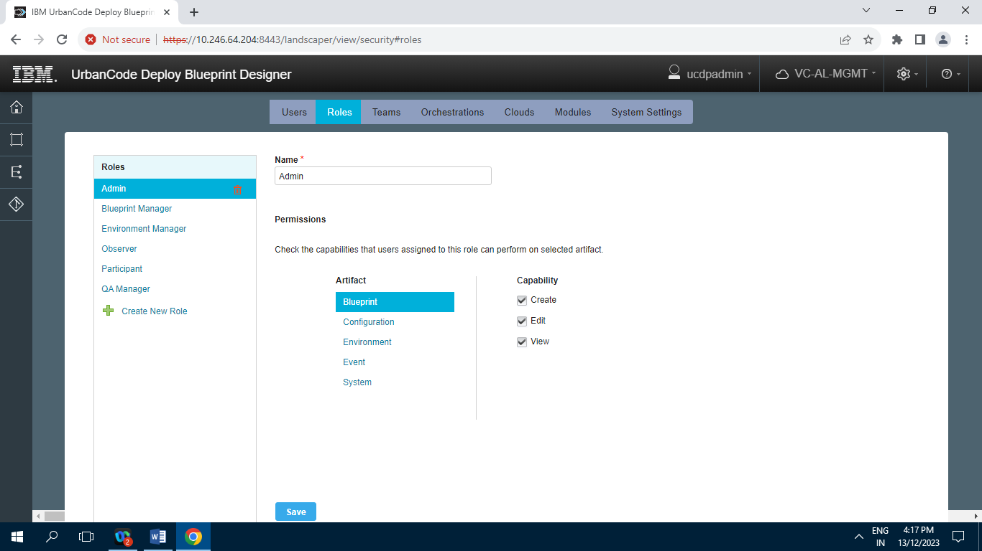

**6.2.2] Blueprint Manager**

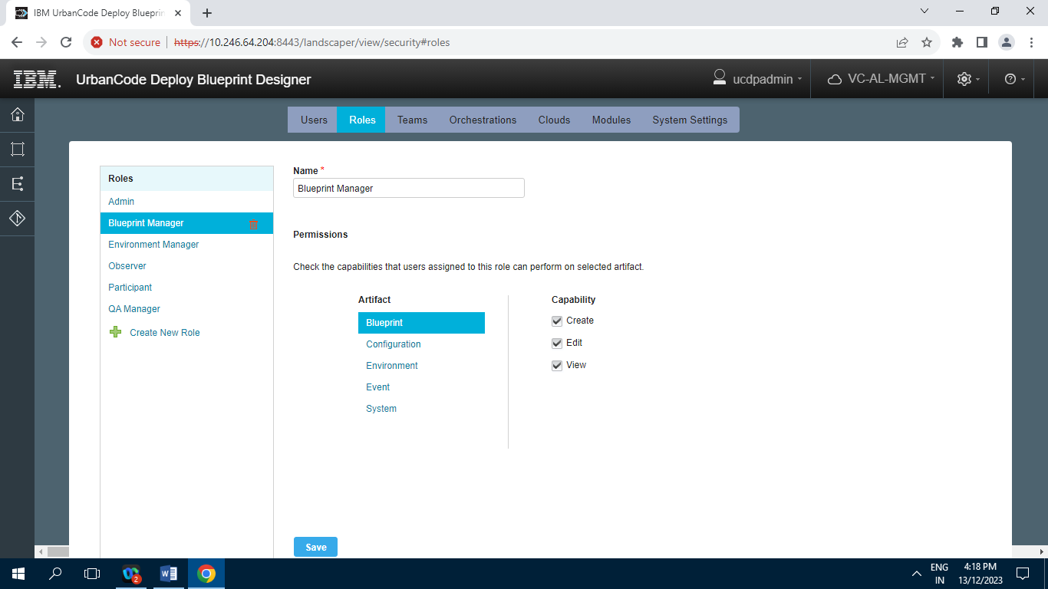

**6.2.3] Environment Manager**

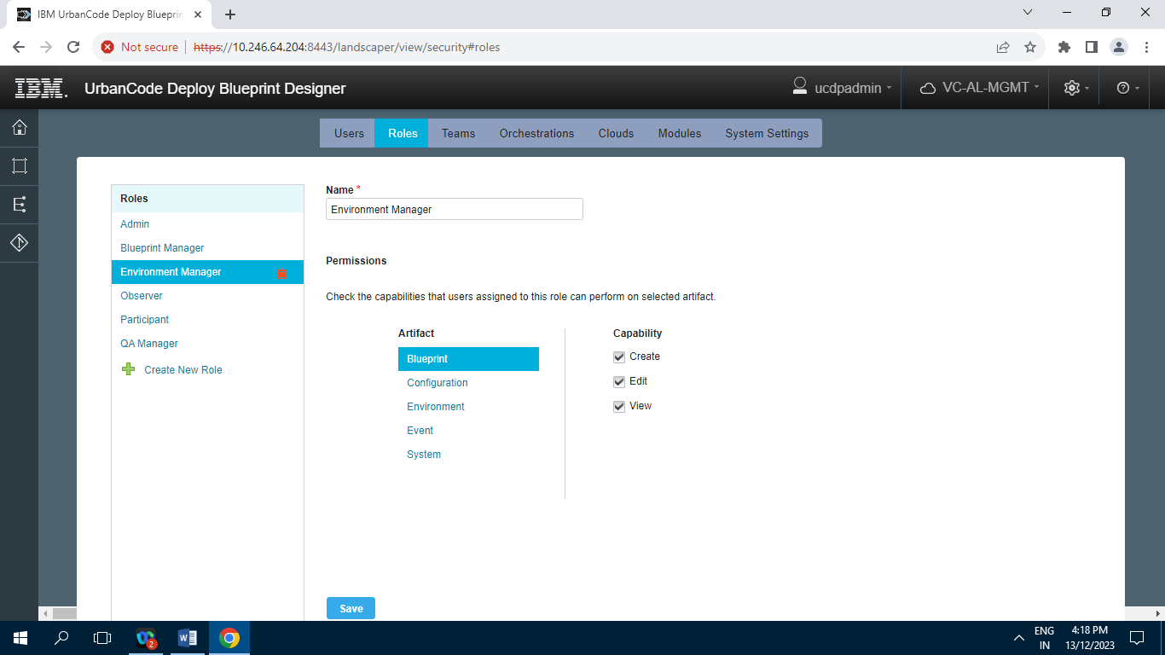

**6.2.4] Observer**

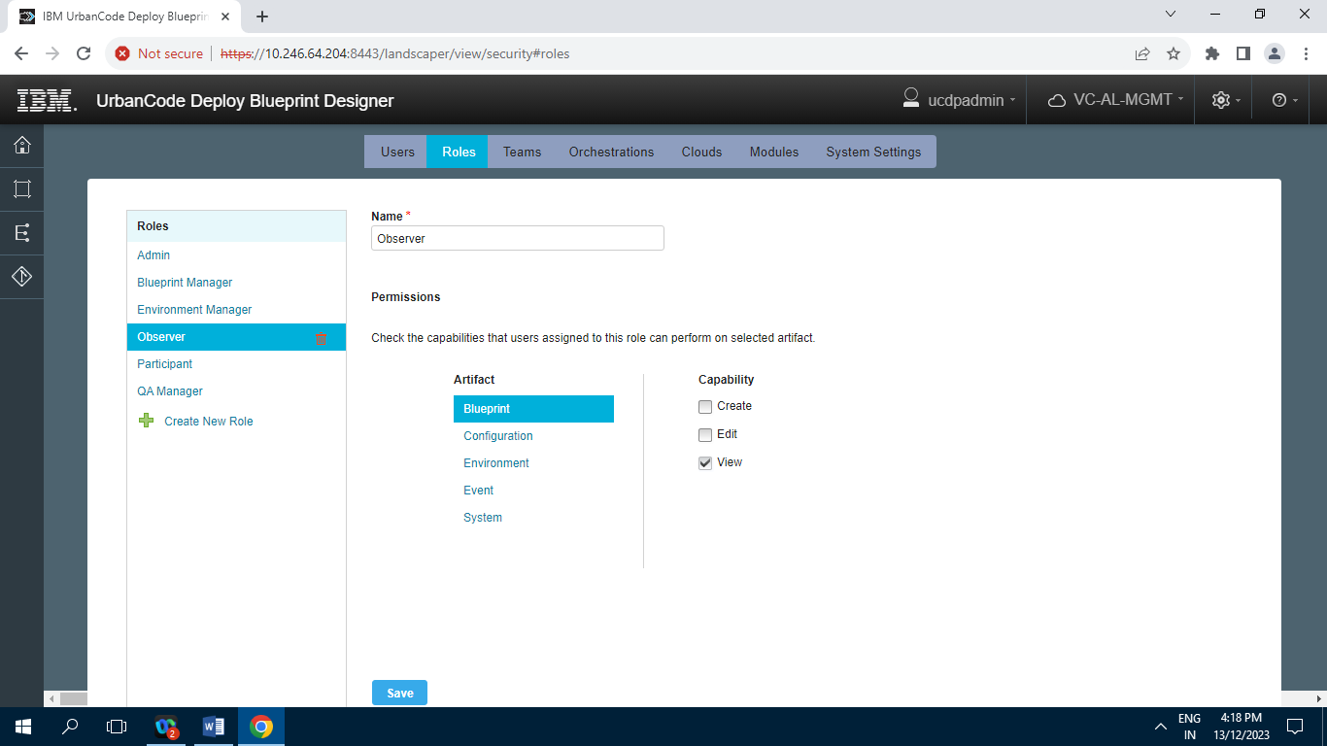

**6.2.5] Participant**

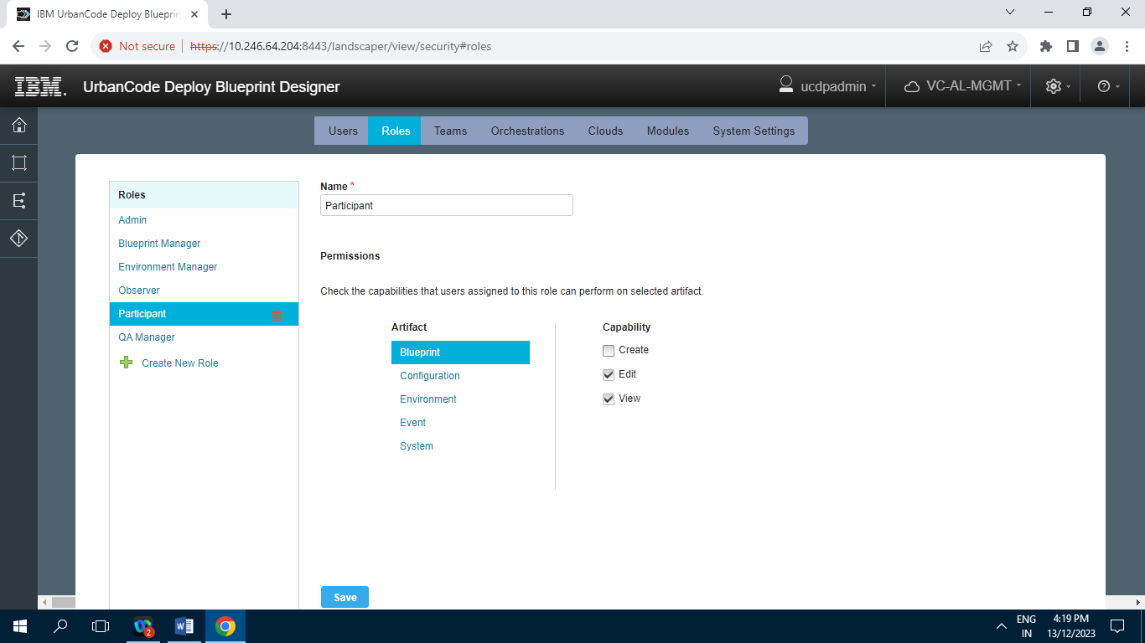

**6.2.6] QA Manager**

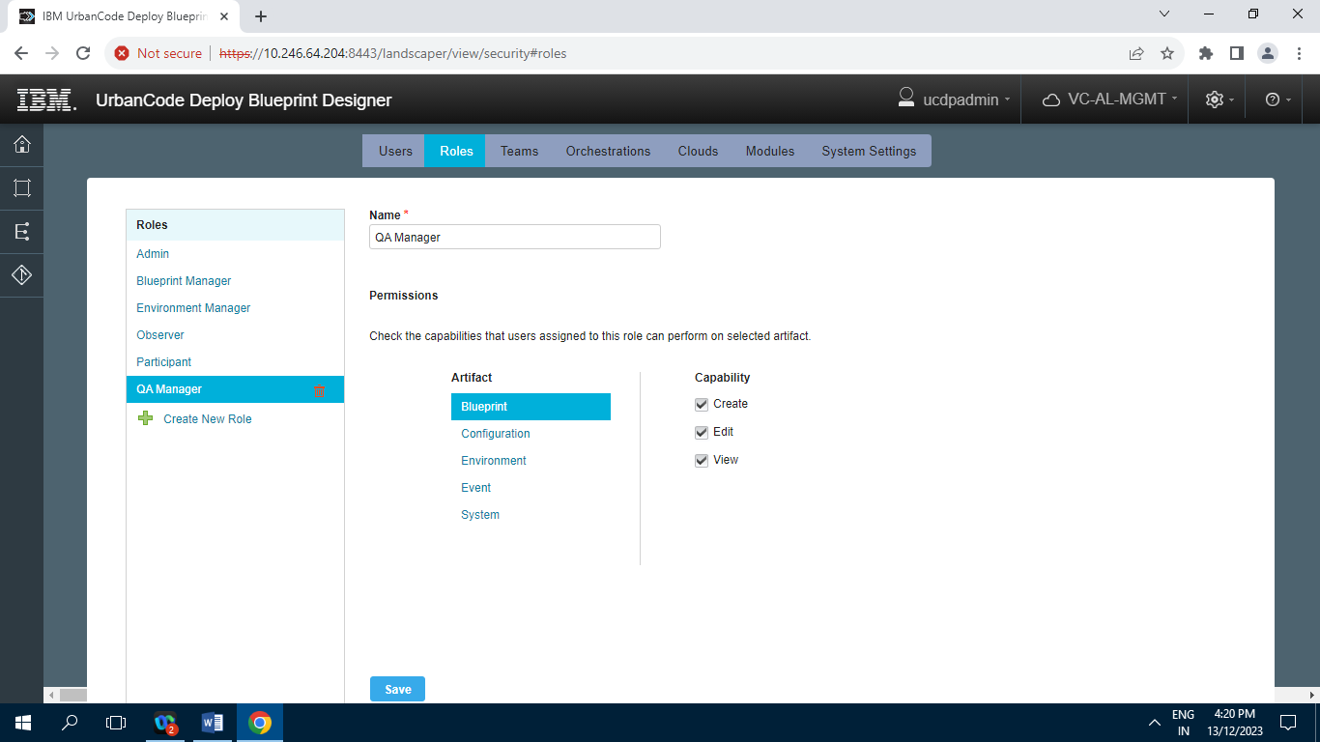

**6.3] Teams**

**6.3.1] Internal Team**

**6.3.1.1] Members**

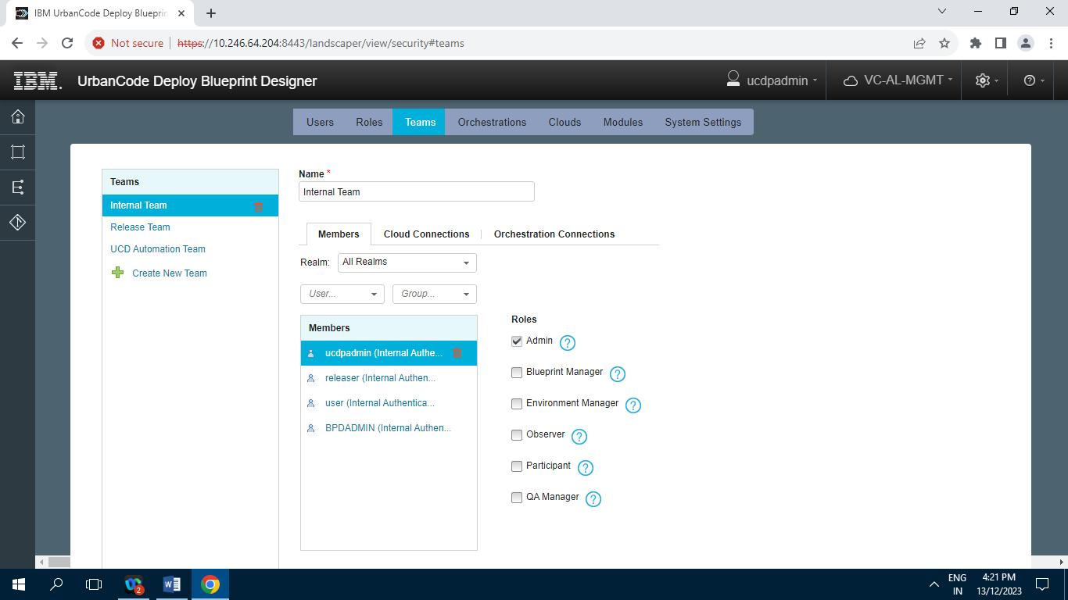

**6.3.1.2] Cloud Connections**

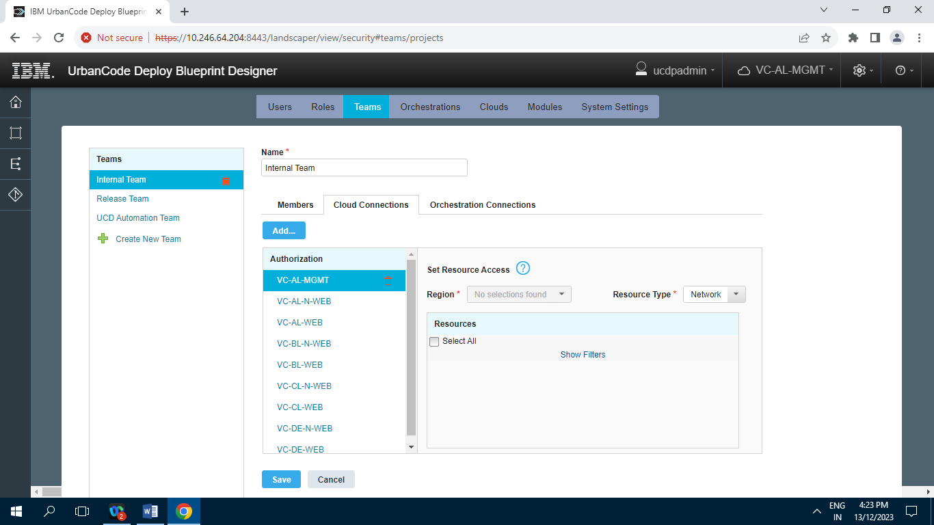

**6.3.1.3] Orchestration Connection**

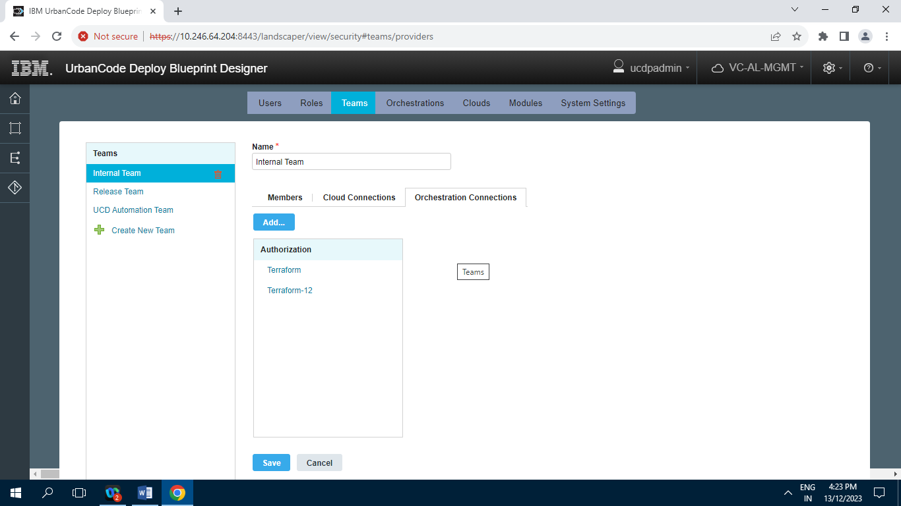

**6.3.2] Release Team**

**6.3.2.1] Members**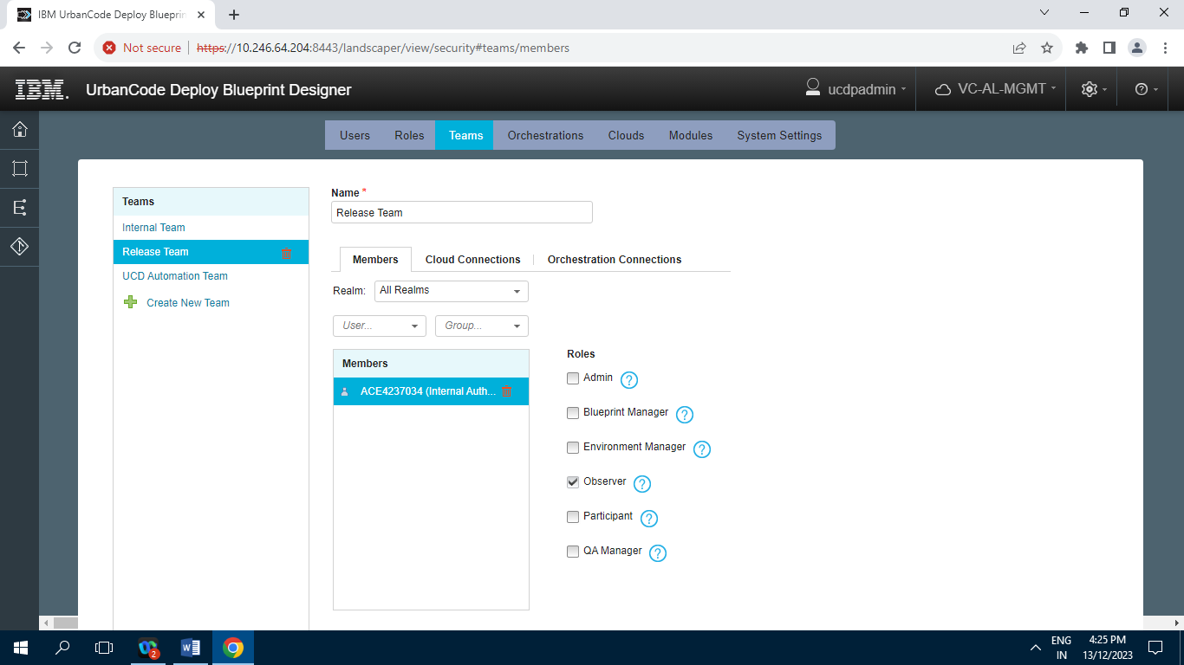

**6.3.2.2] Cloud Connections**

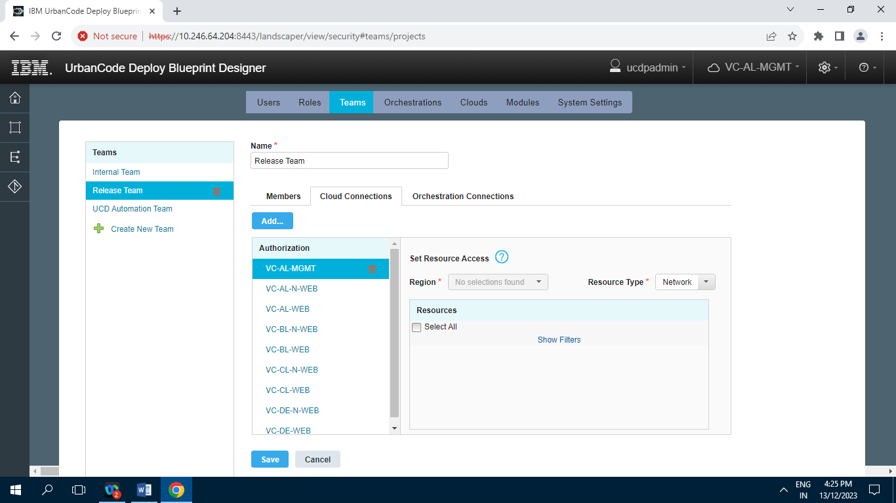

**6.3.2.3] Orchestration Connection**

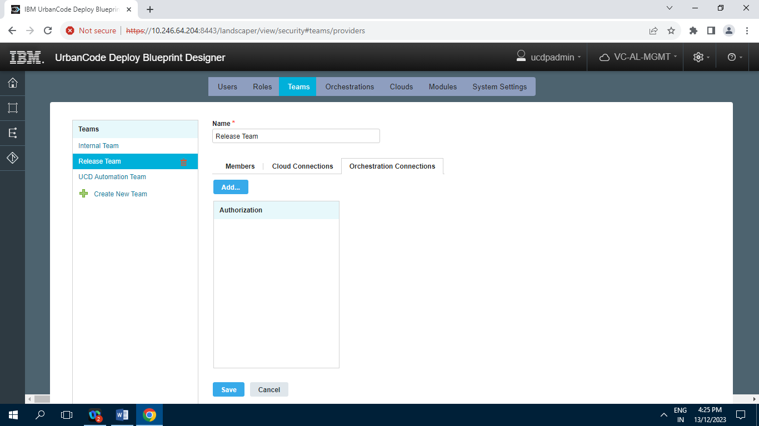

**6.3.3] UCD Automation Team**

**6.3.3.1] Members**

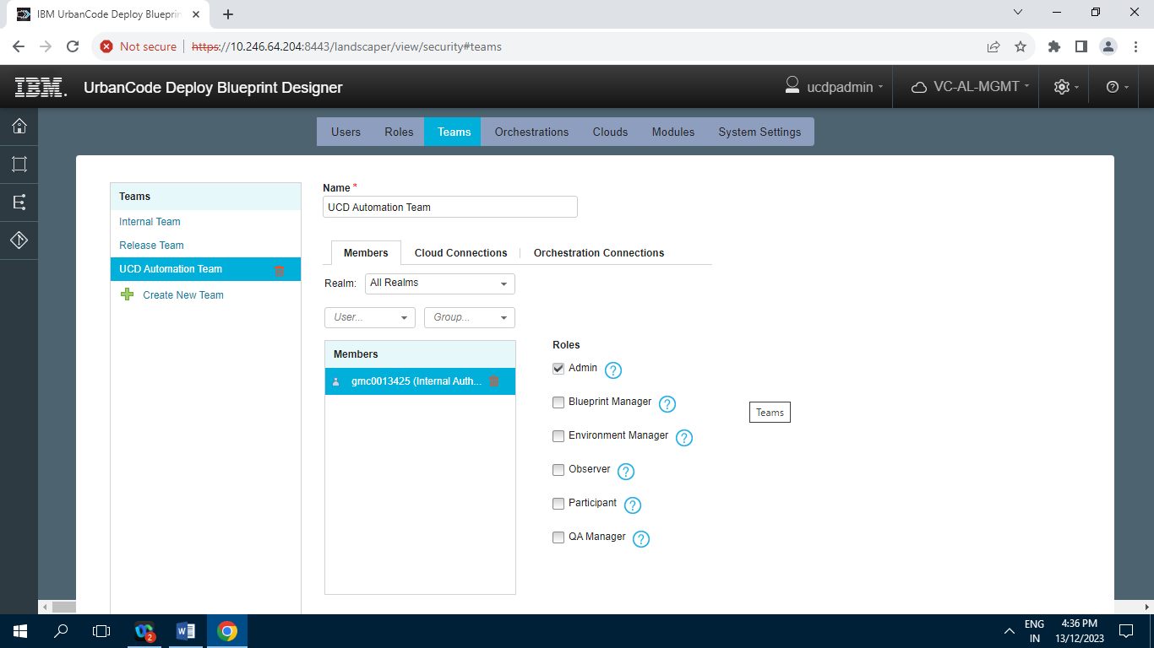

**6.3.3.2] Cloud Connection**

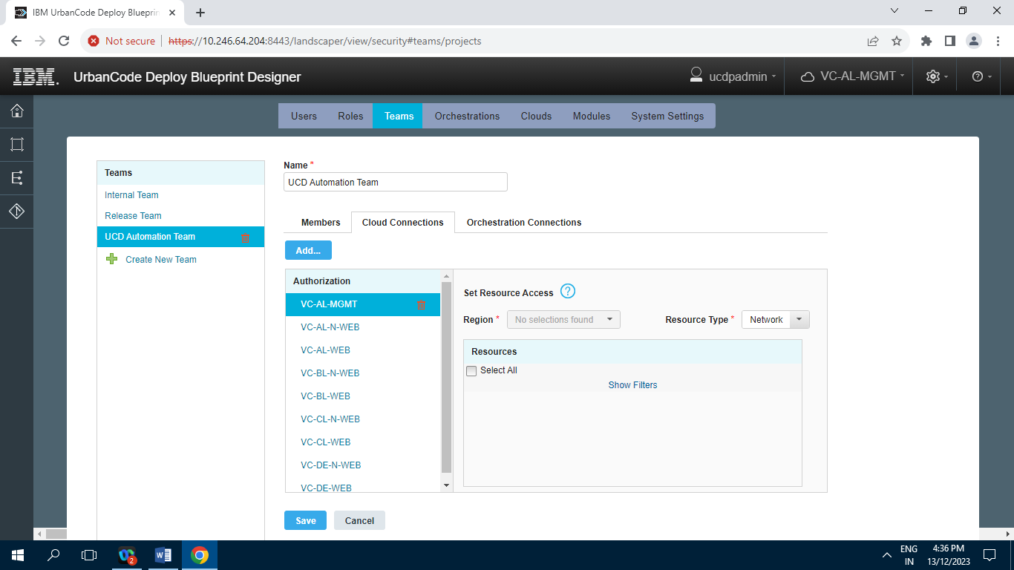

**6.3.3.3] Orchestration Connections**

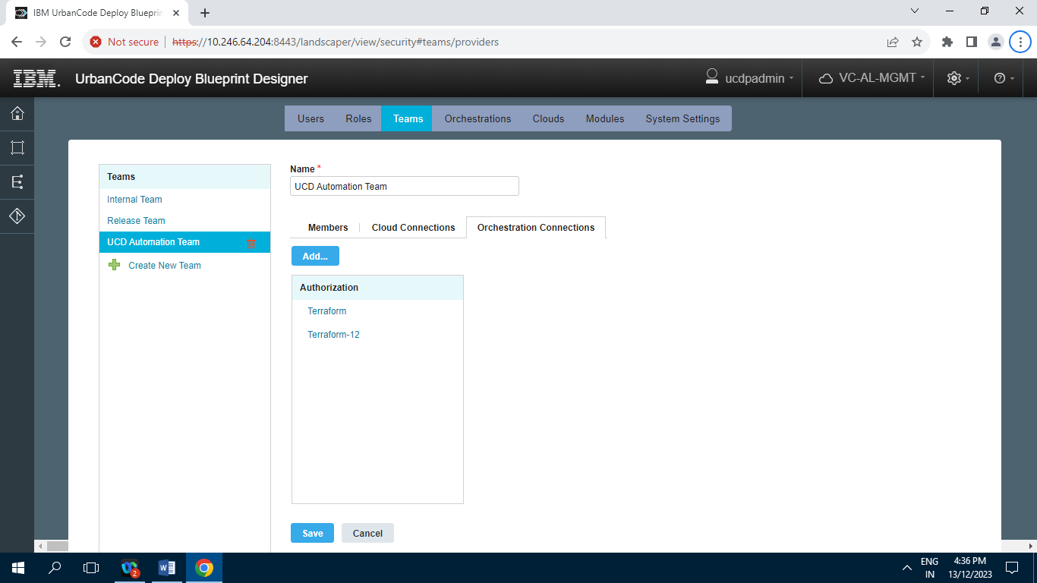

**6.4] Orchestrations**

**6.4.1] Terraform**

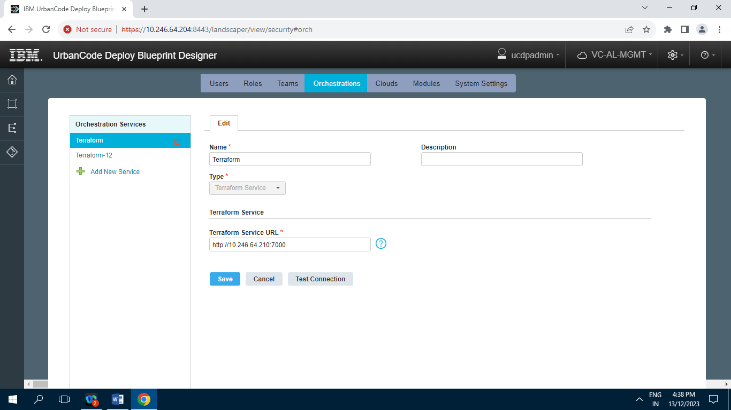

**6.4.2] Terraform-12**

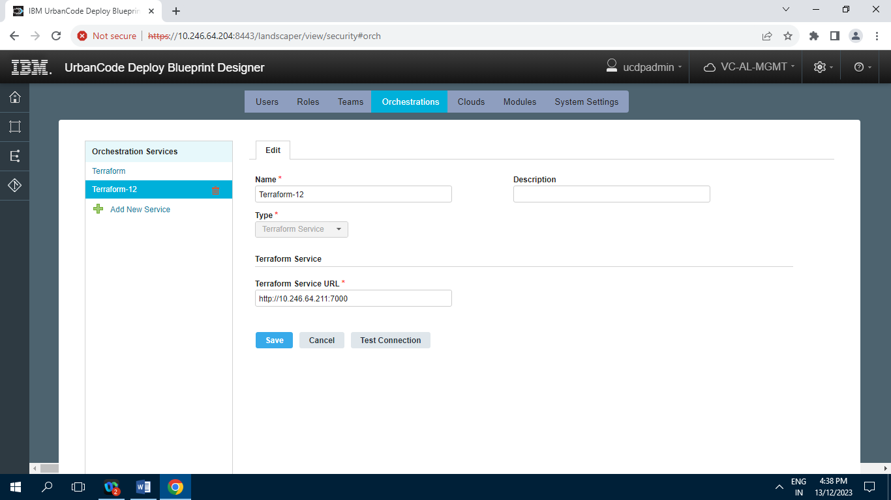

**6.5] Cloud Connections**

**6.5.1] VC-AL-MGMT**

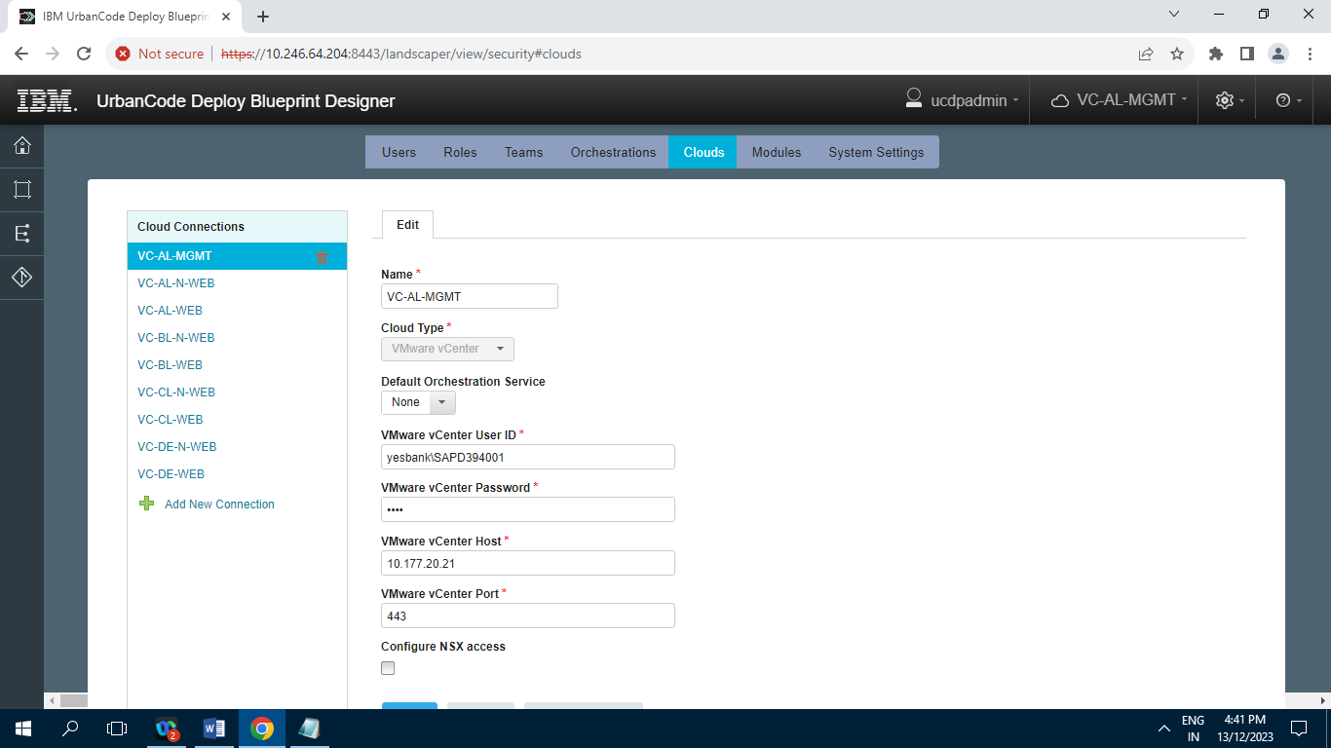

**6.5.2] VC-AL-N-WEB**

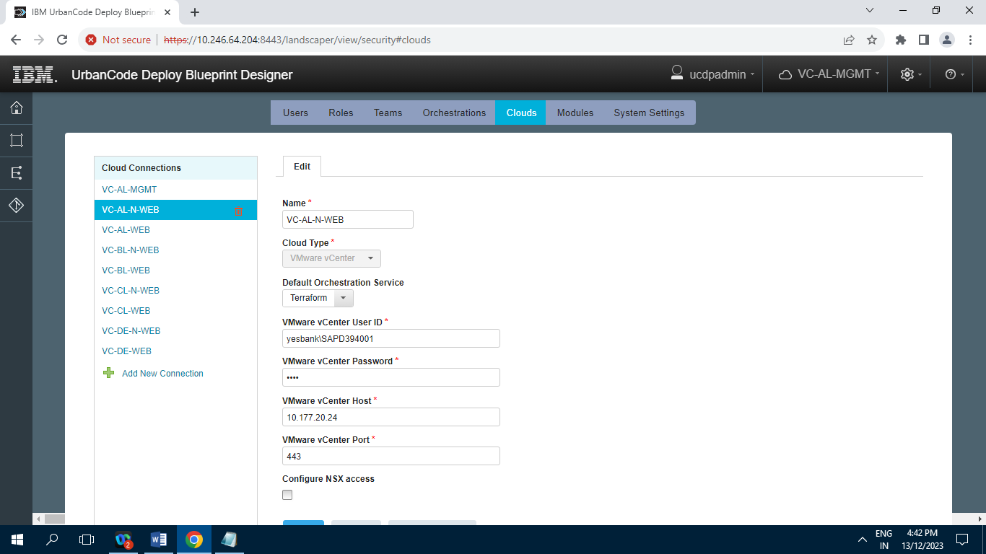

**6.5.3] VC-AL-WEB**

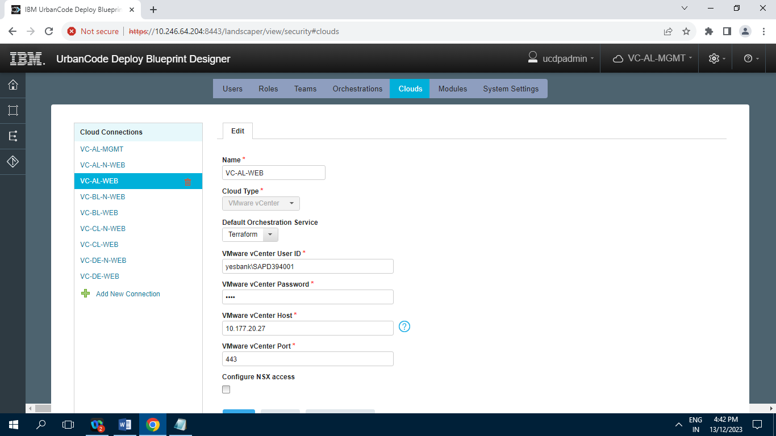

**6.5.4] VC-BL-N-WEB**

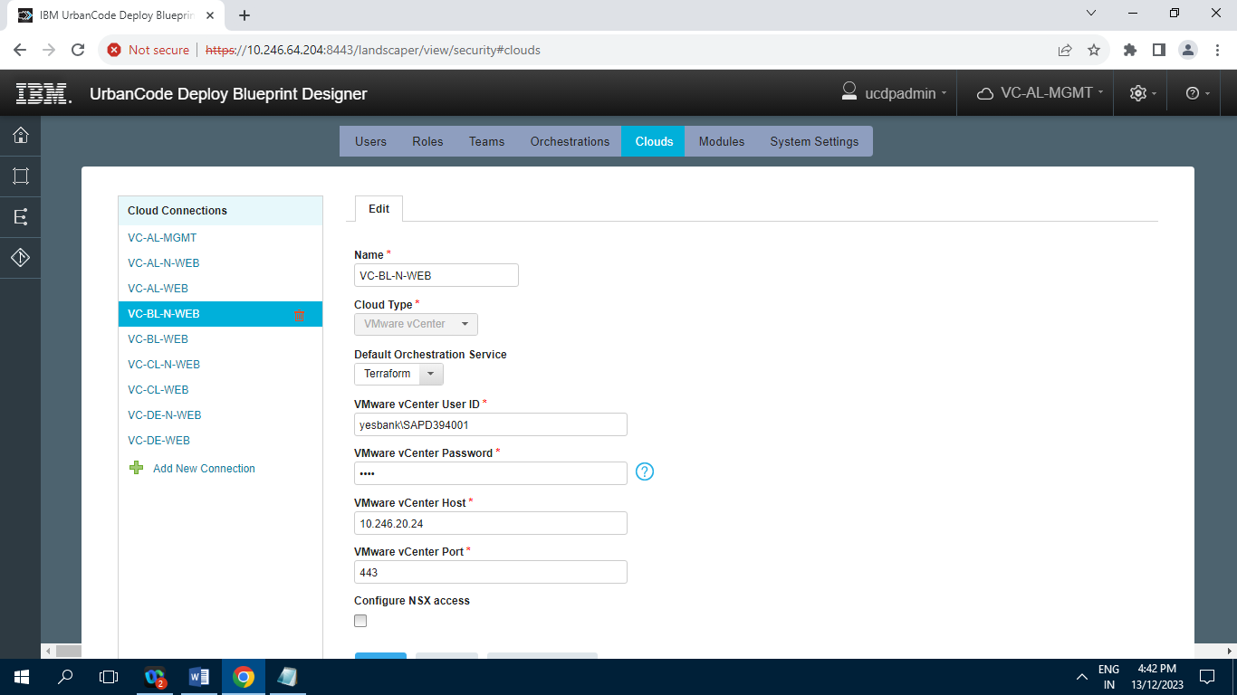

**6.5.5] VC-BL-WEB**

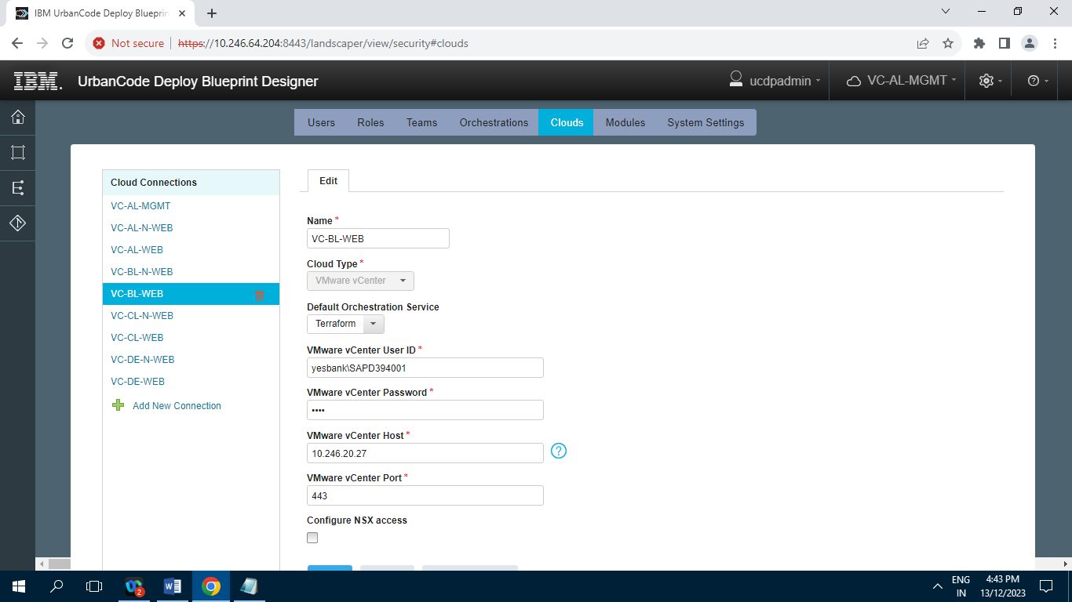

**6.5.6] VC-CL-N-WEB**

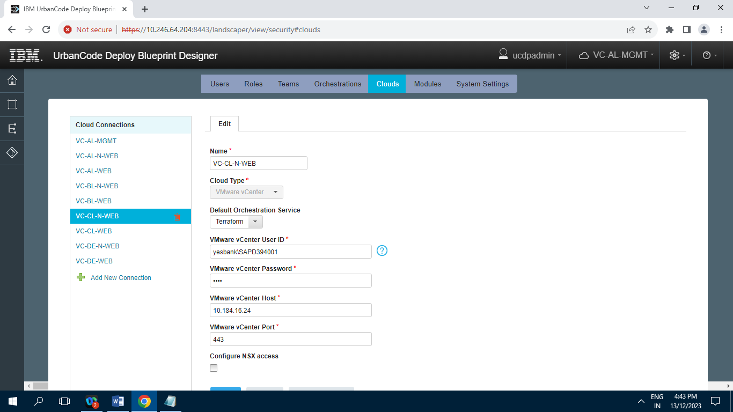

**6.5.7] VC-CL-WEB**

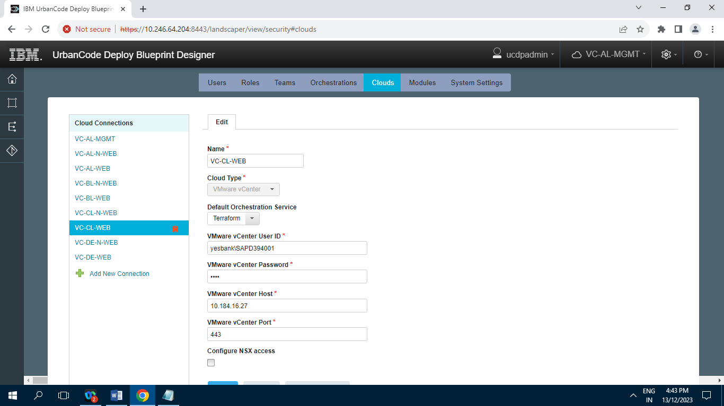

**6.5.8] VC-DE-N-WEB**

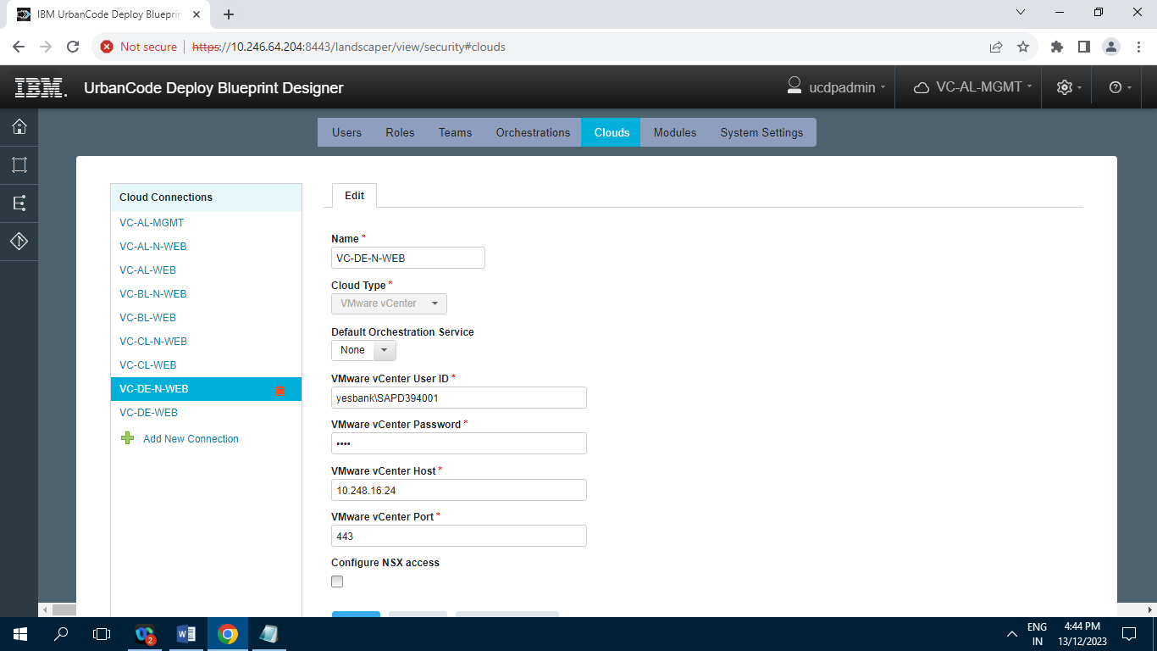

**6.5.9] VC-DE-WEB**

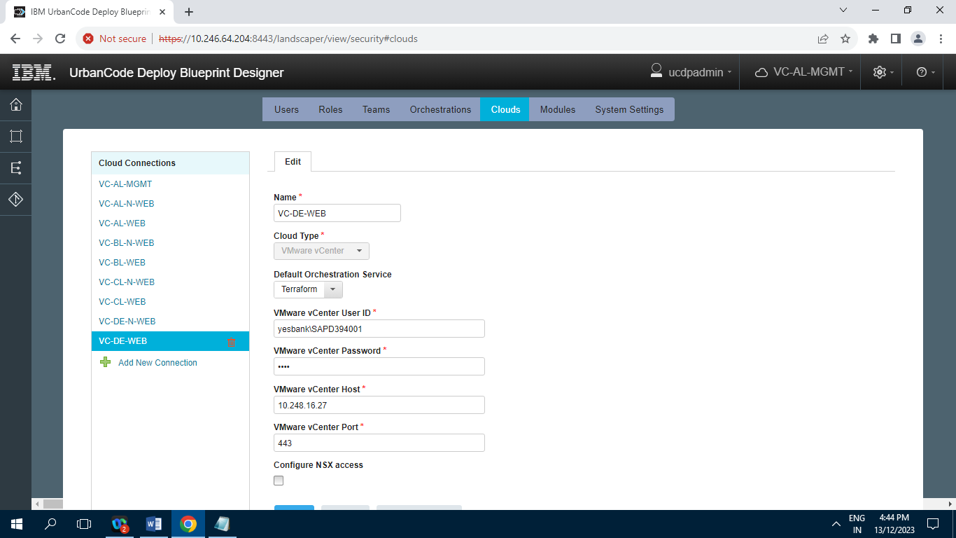

**6.6] Modules**

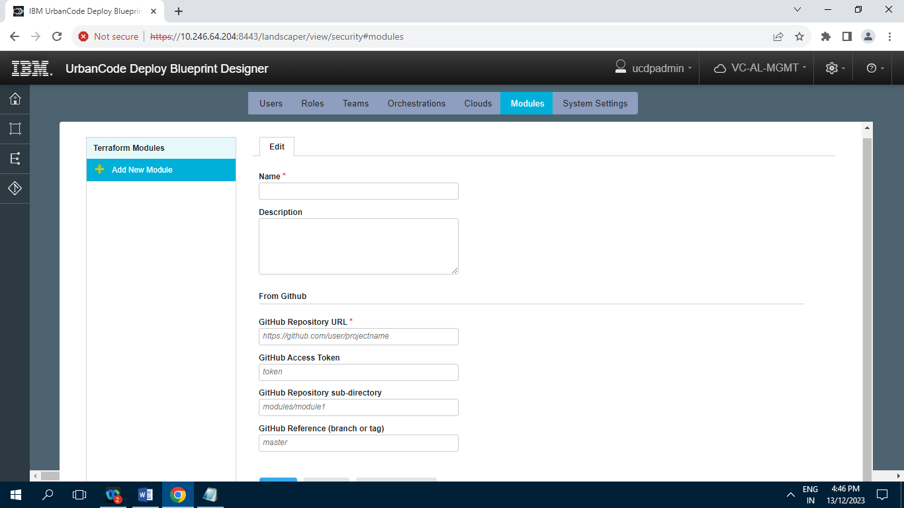

**6.7] System Settings**

